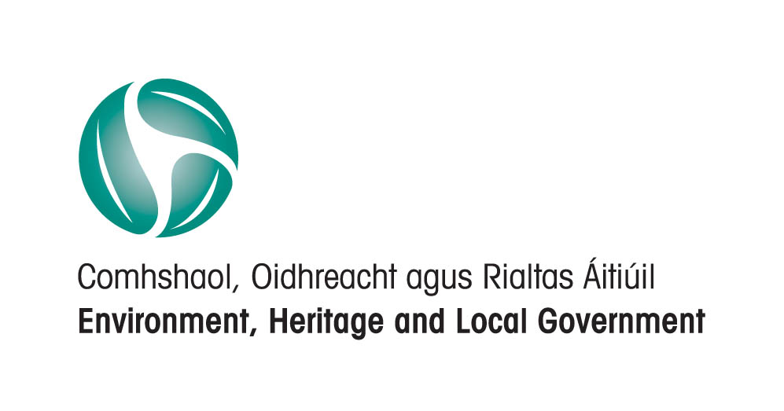   |  | 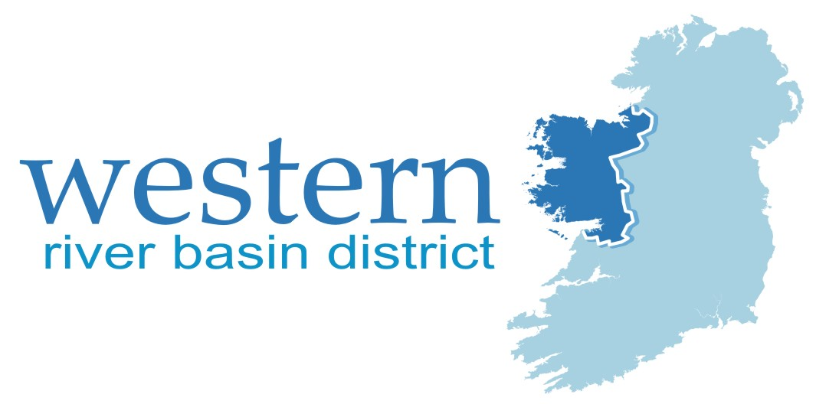

WATER FRAMEWORK DIRECTIVE
ANNEX IV PROTECTED AREAS:
WATER DEPENDENT HABITATS AND SPECIES
AND HIGH STATUS SITES
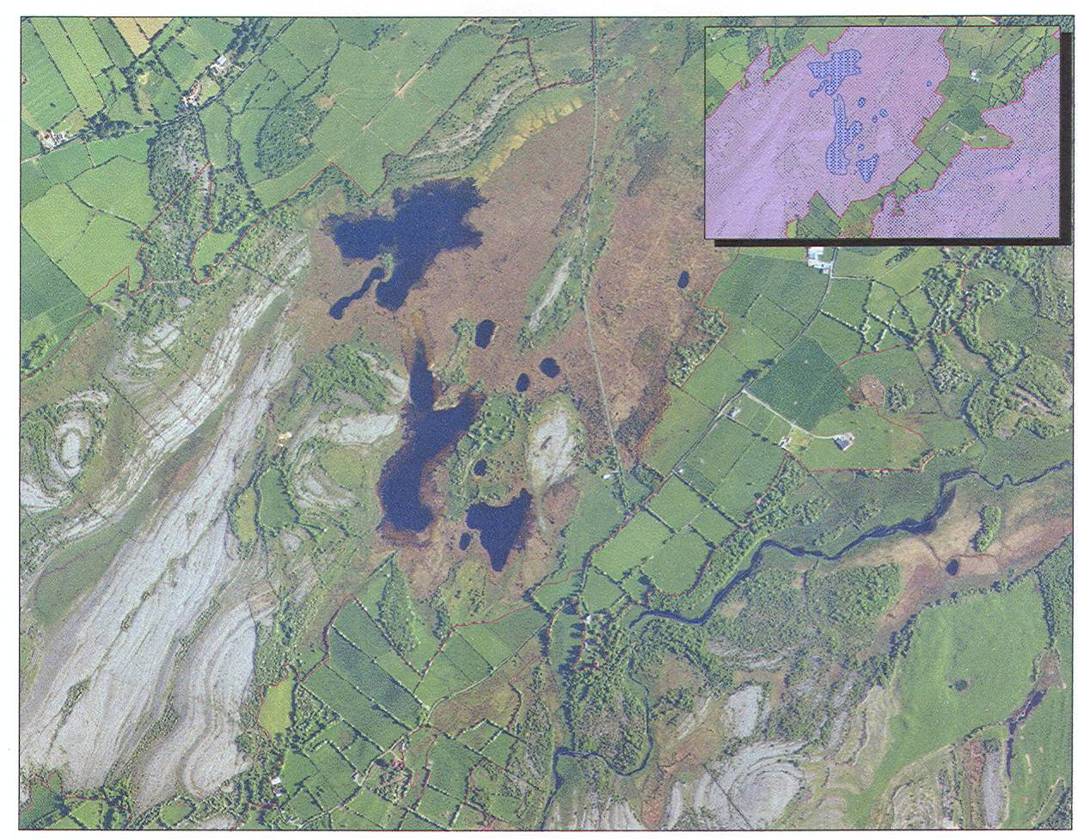

Includes Ordnance Survey of Ireland data
reproduced under OSI license No.
2003/07CCMA/Galway Co. Council

Ballyogan Lough SAC

Moyree River
System SAC

Ground water dependent fen habitats associated with lakes and rivers in SACs in Co. Clare

DECEMBER 2008

GUIDANCE ON MEASURES UNDER THE
HABITATS DIRECTIVE AND FOR HIGH STATUS SITES

WATER FRAMEWORK DIRECTIVE
PROGRAMME OF MEASURES
HIGH STATUS SITES

ANNEX IV PROTECTED AREAS:
WATER DEPENDENT HABITATS AND SPECIES

Databases included:
SAC_Water_Dependency_Dec08
Coastal_lagoons_Sept08
Najas_database_June08
Arctic_char_lakes_Sept08.

Habitats Directive and High Status Measures_Dec08.xls



ELEANOR MAYES
ECOLOGICAL CONSULTANT
Ashford, Co. Wicklow

December 2008

Acknowledgements
This guidance has been prepared in consultation with the National Parks and Wildlife Service, and the Environmental Protection Agency.
The assistance of staff members is gratefully acknowledged

The views expressed in this guidance should be taken as guidance. The
National Parks and Wildlife Service is the Competent Authority with regard to the implementation of the Habitats and Birds Directives
Includes Ordnance Survey of Ireland data reproduced under OSI License No. 2003/07CCMA/Galway Co. Council

TABLE OF CONTENTS

EXECUTIVE SUMMARY 5

1. INTRODUCTION 9

2. LEGISLATION AND CROSS-COMPLIANCE 10
2.1. Water Framework Directive 2000/60/EC 10
2.2. Habitats Directive 92/43/EEC 10
2.2.1. Aims of the Directive. 10
2.2.2. Conservation status assessment and reporting. 12
2.2.3. SAC designated sites. 13
2.3. Birds Directive 79/409/EEC 14
2.4 National legislation - Natural Heritage Area sites. 15
2.5 National legislation – Draft European Communities Environmental Objectives (Surface Waters) Regulations 2008 16

3. water dependent habitats and species. 18
3.1. Habitats Directive Annex 1 listed habitats. 18
3.2. Water dependency in the SAC network. 20
3.3. Coastal marine habitats. 22
3.3.1. Water dependent species associated with coastal marine habitats. 23
3.4. Coastal transitional habitats. 23
3.4.1. Coastal lagoons. 24
3.4.2. Intertidal habitats. 25
3.4.3. Water dependent species associated with coastal transitional habitats. 26
3.5. Coastal onshore habitats. 27
3.5.1. Water dependent species associated with coastal onshore habitats. 29
Petalwort Petalophyllum ralfsii 29
Narrow-mouthed whorl snail Vertigo angustior 29
3.6. Surface water dependent habitats. 30
3.6.1. Lake habitats 3110, 3130, 3140, 3150, 3160. 31
3.6.1.1. Protected species occurring in lake habitats. 33
Najas flexilis. 33
3.6.1.2. Arctic char. 34
3.6.2. River and associated habitats 36
3260: Watercourses of plain to montane levels with the Ranunculion fluitantis and Callitricho-Batrachion vegetation 36
3270 - Rivers with muddy banks with Chenopodion rubri p.p. and Bidention p.p. vegetation 36
91E0 *Alluvial forests with Alnus glutinosa and Fraxinus excelsior
(Alno-padion, Alnion incanae, Salicion albae) 37
6430 Hydrophilous tall herb fringe communities of plains and of the montane to alpine levels 37
3.6.2.1. Annex II listed species of river channels. 38
Fresh water pearl mussel Margaritifera species. 38
3.7. Ground water dependent habitats. 40
3180: Turloughs. 40
7230: Alkaline fen 43
3.7.1 Protected and Annex 2 listed species associated with ground water dependent habitats. 44
Geyer’s whorl snail Vertigo geyeri 44
Desmoulin’s whorl snail Vertigo moulinsiana 45
Yellow marsh saxifrage Saxifraga hirculus. 45
Slender green feather-moss Hamatocaulis (Drepancladus) vernicosus. 46
Rhinolophus hipposideros 46
3.8. Precipitation dependent habitats. 47
3.9. Other water dependent habitats. 50
3.9.1. Other water dependent species. 50
Killarney Fern Trichomanes speciosum 50

4. WATER DEPENDENT HABITATS AND SPECIES: SPATIAL DATA. 51
4.1. Database availability from NPWS 51
4.2. Databases circulated by the Western RBD 52

5. WATER STATUS SENSITIVITY OF WATER DEPENDENT HABITATS AND SPECIES. 54
An interim approach. 55

6. PLANS AND PROJECTS AFFECTING NATURA 2000 SITES. 64
Stage 1: Screening. 67
1. Is there a difference between an Appropriate Assessment and an Article 6 assessment? 67
2. How do you know when an Article 6 assessment is required? 67
3. The Plan or Project is intended to benefit nature conservation in an SAC or SPA, or for a protected species, is an Article 6 assessment required? 68
4. How do you set the boundary of the area to be included in the Article 6 assessment? 69
4.1. Project description 69
4.2. What types of water dependent habitat and species issues potentially arise? 69
5. Is the plan or project likely to have significant effects on N2K (Natura 2000) sites? 71
6. Documenting the Stage 1 decision-making process in the event of a finding of likely significant effects on N2K sites. 72
Stage 2 Assessment. 72
Stage 3 Assessment. 74
Stage 4 Assessment. 75

7. MANAGEMENT AND MEASURES. 76
7.1. Identification of reasons for unfavourable conservation status 76
7.1.1. Measures by NPWS to clarify whether water status is an issue………………….81
7.1.2. Measures by River Basin Districts and implementing agencies to clarify how water status contributes to unfavourable conservation status: 81
7.2. Remedial Measures 81
7.3. Specific measures 81
7.3.1. Measures for Margaritifera species: 81
7.3.2. Measures for Vertigo species 82
7.4. Avoidance of adverse impacts 83
7.4.1. Prevention of adverse impacts through planning, licensing and grant-aiding procedures 83
7.4.2. Prevention of adverse impacts through development and implementation of Codes of Practice 83
7.5. Administrative - Database measures 83
7.5.1. Register of Protected Areas update for SACs 83
7.5.3. Database cross-referencing measures 84
7.5.4. Establishment of a Register of databases relevant to the implementation of the Water Framework Directive. 84
7.6. Measures to encourage appropriate land uses within protected areas for water dependent habitats and species 85
7.7. Measures for High Status Sites 85

BIBLIOGRAPHY. 88

APPENDIX 1: WATER DEPENDENT HABITATS 89

APPENDIX 2: HABITATS DIRECTIVE ANNEX LISTED WATER-DEPENDENT FAUNA SPECIES IN IRELAND 94

APPENDIX 3: LIST OF ANNEX 2 WATER-DEPENDENT PLANT SPECIES IN IRELAND 95

APPENDIX 4: DEFINITION TABLE, SAC WATER DEPENDENCY 96

APPENDIX 5: Impacts and Activities influencing the conservation status of the site (adapted from Natura 2000 form). 101

APPENDIX 6: Natura 2000 sites for which Conservation Management Plans have been prepared 105

APPENDIX 7: RIVERS AND SACs IN WHICH MARGARITIFERA MARGARITIFERA IS CURRENTLY KNOWN TO OCCUR 106

APPENDIX 8: SACS IN WHICH WATER DEPENDENT HABITATS AND/OR SPECIES ARE ASSESSED AS BEING AT UNFAVOURABLE CONSERVATION STATUS (2007/08 reporting for the period 2000 to 2006). 110

APPENDIX 9: NOTES ON COASTAL LAGOONS DATABASE 116

APPENDIX 10: Definition Table: Najas flexilis lakes DATABASE 119

APPENDIX 11: Definition Table: Arctic char DATABASE 120

APPENDIX 12: WFD MEASURES UNDER THE HABITATS DIRECTIVE, AND FOR HIGH STATUS SITES 121

APPENDIX 13: Draft European Communities Environmental Objectives (Surface Waters) Regulations 2008 130
Table 8 130
Table 9 133
Table 10 136
Table 11 137
Table 12 140

EXECUTIVE SUMMARY

The purpose of this guidance is primarily to provide information on Habitats Directive Annex 1 and 2 listed water dependent habitats and species, on their occurrence and conservation status in Ireland generally, and within Special Areas of Conservation (SACs) protected for nature conservation under the Habitats Directive in particular. The maintenance or improvement of the status of water is an important factor in their protection. It also provides measures to protect water bodies at high status as assigned by the EPA under the interim status classification and also catchment areas of monitoring sites indicated to be at high status.

Water dependent Habitats Directive Annex 1 listed habitats and their associated Annex 2 listed species have been grouped into broad themes, with the aim of identifying the landscape, land-use, and water status issues that arise, and how these interact with nature conservation objectives, and the existing pressures on them as identified in the conservation status reporting which has recently been completed by NPWS under Article 17 of the Habitats Directive:

Coastal marine habitats
These are inshore and offshore habitats that occur from the low intertidal down into deep sea water. The main pressures and threats to coastal marine habitats identified by the Article 17 conservation status assessment (carried out by the National Parks and Wildlife Service under the Habitats Directive) were fishing/dredging, extraction, and construction. Water pollution from discharges, and possibly from aquaculture, are potentially impacting some large shallow inlets and bays sites.

Coastal transitional and intertidal habitats
This category include coastal lagoons, a priority Annex 1 listed water dependent habitat. A key feature of lagoons is restricted tidal exchange, which makes them vulnerable to eutrophication. Drainage and modification of hydrography, including the installation of non-return valves resulting in modification of salinity, are also listed as damaging pressures.

Intertidal habitats include sand and mudflats, and salt marsh habitats. They are vulnerable to sediment erosion and re-deposition arising from a number of pressures, and water quality issues also arise. Many individual sites are designated as Special Protection Areas under the Birds Directive because they host internationally important numbers of waterfowl.

Coastal onshore habitats
This category includes sand dune and machair habitats, which depend on coastal geomorphological and sediment transport processes for their formation and continued existence. Groundwater dependent dune slack, and machair wetlands and lake habitats occur within them. For landscape reasons, coastal onshore habitats attract recreational uses and developments, as well as residential development, in addition to agricultural land use. These lead to hydrological pressures including water abstraction, reducing groundwater levels and potentially leading to saline intrusions, and impacting adversely on dune slack and machair habitats and on the water dependent plant and animal species associated with them. Water quality issues also arise in some areas.

Surface water dependent habitats
This category includes Habitats Directive Annex 1 listed lake, river, and associated habitats and species. The Water Framework Directive lake typology differs from the Habitats Directive Annex 1 listed lake types, which are based principally on macrophyte communities. It should be noted that some of the Habitats Directive Annex 1 listed lake habitats are highly oligotrophic (3110, 3140, 3160). It is possible that for some Annex 1 listed lake habitats, high status environmental quality standards may not be stringent enough for the protection of highly oligotrophic lakes. Work remains to be done in elucidating the complex issues that arise. The Draft European Communities Environmental Objectives (Surface Water) Regulations (2008) provide a framework within which the more stringent environmental quality requirements of the Habitats Directive can be addressed.

A number of Annex 2 listed water dependent species occur in rivers, in particular the fresh water pearl mussel species Margaritifera margaritifera and Margaritifera durrovensis, which are critically endangered (IUCN threat category), and require measures to restore favourable conservation status. All Margaritifera populations are at unfavourable-bad conservation status, mainly because of continuous failure to produce new generations of mussels because of the loss of clean gravel beds in rivers. Sub-basin plans are to be prepared for 27 M. margaritifera populations and the sole remaining M. durrovensis population, under the Draft European Communities Environmental Objectives (Freshwater Pearl Mussel) Regulations (December 2008)

The water status pressures identified for Habitats Directive Annex listed lake and river habitats and species relate broadly to the point and diffuse source pressures identified in the Water Framework Directive National Characterisation Report. Hydrological pressures also arise, and are adverse for some sites.

Groundwater dependent habitats
This category includes the Annex 1 listed turlough, Cladium fen, alkaline fen, and petrifying spring habitats. Threats and pressures identified in the conservation status assessments indicate that all are highly vulnerable to hydrological pressures, including water abstractions, arterial drainage, local drainage, and infilling. Water quality issues also arise, and individual sites can be expected to vary considerably in their buffering capacity for nutrient loadings.

With regard to the Water Framework Directive, a key feature of turloughs is that the turlough basin is in direct contact with groundwater. Activities within and adjoining the basin thus constitute a risk to groundwater.

Precipitation dependent habitats
It should be noted that this category, including wet heath, blanket bog and raised bog habitats, are also supported by groundwater (raised bogs), or include ground water dependent habitats and species. They are vulnerable to hydrological and water quality pressures. Land use pressures, including drainage, burning (in an attempt to increase grass cover for livestock grazing), overgrazing, peat cutting, and afforestation within these combined habitats can lead also lead to adverse hydrological and water quality impacts in downstream watercourses. These include reduced low flows, increased peak flows and erosion potential in downstream watercourses, increased suspended solids loads, acidification and nutrient loadings, and increased flood risk.

This guidance builds on and updates the work carried out for the EPA in identifying nature conservation designated areas in the context of the Water Framework Directive (Ó Riain, and Ó Riain et al; 2005). Areas subject to nature conservation designations in Ireland are under on-going review by the National Parks and Wildlife Service (NPWS) of the Department of the Environment, Heritage and Local Government, with the addition of new sites, revisions to the boundaries of existing sites, and changes to the lists of habitats and species Qualifying Interests for which SACs are designated. The information contained in this report is based on the NPWS Habitats Assignment Database Review 2 dated 8th February 2008, additional information from conservation status assessment reporting under the Habitats Directive, and on the NPWS SAC boundary GIS update notified on 4th September 2008.

A number of databases are included with this guidance:

- SAC_Water_Dependency_Dec08
- Coastal_lagoons_Sept08
- Najas_database_June08
- Arctic_char_lakes_Sept08
- Habitats Directive and High Status Measures_Dec08.xls

The SAC Water Dependency GIS database prepared in association with this guidance updates the Register of Protected Areas for water dependent habitats and species in the Special Area of Protection (SAC) component of the Natura 2000 site network.

The coastal lagoons, Najas, and Arctic char databases include information relevant to the identification of High Status Sites under the Water Framework Directive. The coastal lagoons (priority Annex 1 listed habitat) database refers to individual sites that are listed as having favourable or unfavourable conservation status under the Habitats Directive Article 17 reporting for the period 2000 to 2006, and indicates whether an anthropogenic source of unfavourable conservation status has been identified. Najas flexilis is an Annex 2 listed plant that occurs in lakes that are transitional between hard water and soft water types, conservation status assessments are available for these individual lakes. Arctic char are not listed in Annexes to the Habitats Directive, but have been included as a water dependent species because of their threatened status, high lake water quality requirement and hence usefulness as an indicator species, and vulnerability to water abstraction.

This guidance also refers to the Conservation Status reporting which has recently been completed by NPWS under Article 17 of the Habitats Directive. The 2007/08 reporting, for the period 2000 to 2006, is the first to be completed. The reporting indicates unfavourable conservation status for virtually all water dependent habitats and for some water dependent species, in particular the fresh water pearl mussel species Margaritifera margaritifera and Margaritifera durrovensis, which are critically endangered (IUCN threat category). It follows that for some water bodies, measures will be required under the Habitats Directive.

A suite of measures under the Habitats Directive is included in this guidance (Section 7). Many of these measures are also applicable to High Status sites under the Water Framework Directive. High Status and Habitats Directive measures are coded and cross-referred (Appendix 12 / Habitats Directive and High Status Measures_Dec08.xls). Additional measures are given for High Status sites which link the water quality requirements to the water quality objectives and standards set out in the Draft European Communities (Environmental Objectives) Regulations 2008.

The sensitivities of individual water dependent Annex 1 listed habitats and Annex 2 listed species to hydrological and water quality pressures, and to direct impacts, are considered in Section 5. Guidance on the appropriate assessment of plans and projects affecting Natura 2000 sites is given in Section 6.

1. INTRODUCTION

The purpose of this guidance is to provide information on water dependent habitats and species that are of nature conservation importance, and on their occurrence in Protected Areas in Ireland. The maintenance or improvement of the status of water is an important factor in their protection. Habitats and species have been grouped into broad themes, with the aim of identifying the landscape, land-use, and water status issues that arise, and how these interact with nature conservation objectives. The SAC Water Dependency GIS database prepared in association with this guidance updates the Register of Protected Areas for water dependent habitats and species in the Special Area of Protection (SAC) component of the Natura 2000 site network.

This report builds on and updates the work carried out for the EPA in identifying nature conservation designated areas in the context of the Water Framework Directive (Ó Riain, and Ó Riain et al; 2005). Areas subject to nature conservation designations in Ireland are under on-going review by the National Parks and Wildlife Service (NPWS) of the Department of the Environment, Heritage and Local Government, with the addition of new sites, revisions to the boundaries of existing sites, and changes to the lists of habitats and species Qualifying Interests for which sites are designated. The information contained in this report is based on the NPWS Habitats Assignment Database Review 2 dated 8th February 2008, additional information from conservation status assessment reporting under the Habitats Directive, and on the NPWS SAC boundary GIS update notified on 4th September 2008.

This guidance also refers to the Conservation Status reporting which has recently been completed by NPWS under Article 17 of the Habitats Directive. The 2007/08 reporting, for the period 2000 to 2006, is the first to be completed. The reporting indicates unfavourable conservation status for virtually all water dependent habitats and for some water dependent species, in particular the fresh water pearl mussel species Margaritifera margaritifera and Margaritifera durrovensis, which are critically endangered (IUCN threat category). It follows that for some water bodies, measures will be required under the Habitats Directive.

A suite of measures under the Habitats Directive is included in this guidance. Many of these measures are also applicable to High Status sites under the Water Framework Directive. High Status and Habitats Directive measures are coded and cross-referred. Additional measures are given for High Status sites which link the water quality requirements to the water quality objectives and standards set out in the Draft European Communities (Environmental Objectives) Regualtions 2008.

2. LEGISLATION AND CROSS-COMPLIANCE

2.1. Water Framework Directive 2000/60/EC

Article 6 of the Water Framework Directive 2000/60/EC requires that “Member States shall ensure the establishment of a register or registers of all areas lying within each river basin district which have been designated as requiring special protection under specific community legislation for the protection of their surface water and ground water or for the conservation of habitats and species directly depending on water.”

Annex IV of the Water Framework Directive defines protected areas for the conservation of habitats and species as follows:

“1. The register of protected areas required under Article 6 shall include the following types of protected areas:

1. (v) areas designated for the protection of habitats or species where the maintenance or improvement of the status of water is an important factor in their protection, including relevant Natura 2000 sites designated under Directive 92/43/EEC and Directive 79/409/EEC.

- The summary of the register required as part of the river basin management plans shall include maps indicating the location of each protected area and a description of the Community, national or local legislation under which they have been designated.”

The next stage of implementation is to assign measures to water bodies under the Habitats and Birds Directives, where the maintenance and improvement of the status of water is required to improve the conservation status of certain habitats and species.

2.2. Habitats Directive 92/43/EEC

2.2.1. Aims of the Directive.
This Directive aims to protect and promote biodiversity, and includes requirements to maintain and restore the most rare and threatened habitats and species in the EU at a favourable conservation status. These habitats and species are listed in Annexes to the Directive; Member States are required to protect Annex 1 listed habitats and Annex II listed species through the designation, conservation, and appropriate management of a network of Special Areas of Conservation (SACs) throughout Europe. Specific protection is required at a national level for species listed in Annex IV and Annex V. A total of 231 European natural habitat types are listed in Annex 1 of the Habitats Directive. Sixty two Annex 1 listed natural habitats occur in Ireland; 47 of them have been defined as water dependent (see Section 3 and Appendix 1).

When an SAC is proposed for designation under the Habitats Directive, a Natura 2000 form is prepared by the National Parks and Wildlife Service. This assigns a unique Site Code to the site, and provides details of the conservation interests of the site. The Annex listed habitats and species for which the site is specifically designated are referred to as the “Qualifying Interests” of the site. Other Annex listed habitats and species present within the site are also noted when the site is surveyed; others may be found to be present during subsequent specialist surveys.

SAC sites contribute to the Natura 2000 network, and are required to be included as Protected Areas under the Water Framework Directive where they are of interest for water dependent habitats or species. In general, the most extensive and intact areas where Annex 1 listed habitats and species occur are protected within the SAC network.

It is important to note that Annex listed water dependent habitats and species occur outside the current Natura 2000 site network, and the Directive and subsequent case law indicate that these should be protected under national legislation and other measures to promote biodiversity. They occur within Natural Heritage Areas (NHA) and proposed Natural Heritage Areas (pNHA). Habitat and species inventory work by NPWS is on-going, and indicates that there are significant numbers of sites for habitats and species which are not covered by formal conservation designations currently. These include:

- sites which are of conservation importance and may merit a conservation designation under EU or national legislation

- sites which support non-significant examples/populations of Annex listed water dependent habitats and species, which may not merit a conservation designation under EU legislation, but which may merit a designation under national legislation, or may be important locally as stepping stones/reservoirs for biodiversity

- sites which may have lost much of their conservation value (through arterial drainage schemes in the past, for example), some of which may still be locally important as stepping stones/reservoirs for biodiversity. Specific examples include areas affected by the arterial drainage of the Clare River in Co. Galway, and in karst areas of the Moy catchment in Mayo.

At present, NPWS does not have sufficient information to distinguish between these three categories for all water dependent habitats and species. In the context of the Water Framework Directive, the occurrence of water dependent habitats and species (including within designated sites, in sites meriting designation, in the wider countryside, and in sites which may have lost much of their conservation value) is relevant to risk assessment, status classification, and also to programmes of measures. Sites that have lost much of their conservation value, for example some of the turloughs affected by the arterial drainage of the Clare River in Co. Galway, may now be in intensive agricultural use or subject to un-sewered pressures from housing. Activities within the surface/ground water catchments of these sites will have a direct impact on ground water status.

2.2.2. Conservation status assessment and reporting.
The Habitats Directive includes a requirement on Member States to report on the implementation of measures taken under the Directive:

Article 17 section 1 of the Habitats Directive states
“Every six years from the date of expiry of the period laid down in Article 23, Member States shall draw up a report on the implementation of the measures taken under this Directive. This report shall include in particular information concerning the conservation measures referred to in Article 6 (1) as well as evaluation of the impact of those measures on the conservation status of the natural habitat types of Annex I and the species in Annex II and the main results of the surveillance referred to in Article 11. The report, in accordance with the format established by the committee, shall be forwarded to the Commission and made accessible to the public.”

The first Article 17 reporting on the conservation status of habitats and species for the period 2000 to 2006 was completed by NPWS in 2008; a summary report, and details of the findings for individual habitats and species, are available on the website www.npws.ie Article 17 reporting covers the entire national range of a habitat of species, and includes areas outside the SAC and other conservation site designation network as well as those within it.

With regard to Annex 1 habitats, Article 17 reports on five categories:
- overall range of occurrence
- area covered
- structure and functions (condition)
- future prospects in view of current pressures and future threats, and potential for remediation
- the overall conservation status

The reporting procedure provides for four possible outcomes in each reporting category :

Conservation Status | Colour
Favourable | Green
Unfavourable - Inadequate | Amber
Unfavourable - Bad | Red
Unkown: where there are insufficient data to support a conclusion on status | Grey

For the structure and functions (condition) of a habitat to be classed as favourable, the habitat must be in good condition, with no significant deterioration in habitat quality, and no significant pressures currently threatening the habitat. An Unfavourable – Bad classification arises if more than 25% of the overall national area of the habitat is at unfavourable status. An unfavourable-inadequate assessment arises in situations intermediate between favourable and unfavourable-bad. The overall assessment of conservation status is based on the outcome of the assessments in the categories range, area, structure and functions (condition), and future prospects. An Unfavourable – Bad overall assessment is made where one or more of the first four categories have been given an Unfavourable – Bad assessment.

Species reporting considers the range of occurrence, the population of the species including reproductive success and survival/recruitment of juveniles into the adult population, the condition of the habitat of the species, current pressures and future threats, and the future prospects for the species, as the basis for the overall conservation status assessment.

The details of the Article 17 assessments are available on the NPWS website, including the reporting form, the backing document with detailed information, and a map showing the range and distribution for each Annex listed habitats and species in Ireland on a 10km square basis:
http://www.npws.ie/en/PublicationsLiterature/HabitatsDirectivereport07/Habitats/
http://www.npws.ie/en/PublicationsLiterature/HabitatsDirectivereport07/Species/

The outcome of the conservation status assessments for water dependent habitats and species are referred to in Section 3 of this report. The next Article 17 reporting is due in 2013; work on individual habitats and species by NPWS is on-going.

2.2.3. SAC designated sites.
There are currently 423 SAC site areas in Ireland, 412 of which have been formally adopted by the European Commission and are listed in Commission decision 2008/23/EC. A further 11 SACs have been transmitted to, but not yet formally adopted by, the European Commission. The designation process occurs over several stages:

- A Member State proposes a site as eligible for designation, and the site is advertised nationally and locally as a proposed candidate SAC as part of a consultation process
- A map and Natura 2000 data form relating to the site is transmitted to the EU Commission via formal diplomatic channels
- The EU Commission adopts the site as a confirmed Site of Community
Importance (SCI)
- The Member State formally designates the site as an SAC

The SAC_Water_Dependency database accompanying this guidance includes two SAC fields: the sites listed in the SAC field have been adopted by the EU Commission, and the sites listed in the pSAC field have been transmitted, but not yet adopted by the EU Commission. Please note that the SAC_Water_Dependency database does not include the four off-shore cold-water coral SACs, which lie outside the RBD areas.

Further SAC sites are likely to be identified and notified as proposed candidate SACs, particularly in the marine area, and as modifications to pre-existing SACs.

The legal requirements under the Habitats Directive for conservation and appropriate management apply to all SAC sites from the date of their first notification as a proposed candidate SAC site.

Mapping of Special Areas of Conservation (SACs) in Ireland
SAC sites are mapped by NPWS, and are available from the NPWS website (www.npws.ie). Many individual SACs comprise a number of mapped polygons, reflecting county boundaries that lie within the site, or the fact that for an individual SAC the qualifying interests are specific features in the landscape which are separated by lands which are not of conservation importance, e.g Kilroosky Lough Cluster (Site Code 001786). Currently there are some 1,850 SAC mapped polygons ascribed to 419 coastal and onshore SACs (note that the four off-shore cold-water coral SACs are not included). For the purpose of this report, polygons referring individual SACs have been linked in the SAC_Water_Dependency database, because the data used in the attribute table refers to the entire area of each individual SAC.

Refer also to Section 4 on Spatial Data

2.3. Birds Directive 79/409/EEC

This Directive aims to provide long-term protection and conservation of all bird species naturally living in the wild within the EU through the conservation, maintenance or restoration of the biotopes and habitats. Measures include the designation of Special Protection Areas (SPAs) for those species listed in Annex 1 of the Birds Directive, and for regularly occurring migratory species. SPAs contribute to the EU – wide network of Natura 2000 sites. SPAs are subject to the same legal protection and provisions as SACs designated under the Habitats Directive (legal obligations under Article 4 of the Birds Directive (79/409/EEC) have been superseded by Article 6 of the Habitats Directive) and are included as Protected Areas under the Water Framework Directive.

Satisfactory water quality and hydrological regime are often essential factors in SPAs; as is the prevention of excessive disturbance due to human activity. Winter flooding is often an important feature of these sites, for example Lough Mask SPA, Lough Ree SPA, the Middle Shannon Callows SPA, and the Blackwater Callows SPA in Co. Waterford. Wetland habitats are often important components of inland SPAs designated for Annex 1 listed bird species and for internationally important concentrations of migratory waterfowl, for example wet grassland and marsh habitats which depend on seasonal flooding. These habitats are generally mesotrophic in character.

Many SPAs occur in transitional waters, including lagoons (e.g. Tacumshin Lake SPA and Lady’s Island Lake SPA in Co. Wexford), and estuaries and bays with extensive intertidal sand and mudflats (e.g. Dundalk Bay, Dublin Bay, Cork Harbour, and Inner Galway Bay SPAs), in which the habitats present are Annex 1 listed under the Habitats Directive.

Ireland’s SPA network has recently undergone a major review, and the roll out of the notification and subsequent designation of both old and new sites is underway. The majority of the SPAs will be designated for wintering waterbirds and for breeding seabirds. Both of these groups are water dependent, but a definitive list of water dependent species has not been compiled to date. Recent SPA designations for hen harrier and chough generally include water dependent habitats which are used by these species.

2.4 National legislation - Natural Heritage Area sites.

As of June 2008, there are 148 Natural Heritage Areas (NHA) fully designated by Statutory Instrument; all of these include bog habitats. An additional seven sites have been notified (all are sites important for birds), but have not yet been designated by S.I. These sites are designated, and notified as proposed for designation, under the Wildlife (Amendment) Act of 2000. A further suite of 1,135 sites were advertised in 1995 as proposed natural Heritage Areas (pNHAs) and await review and selection for full designation under the Wildlife (Amendment) Act. The process of NHA identification, notification and designation is on-going; all sites are subject to the requirements of the Wildlife (Amendment) Act from the time of first notification.

Many SAC sites are also covered by pNHA sites; it should be noted that the site boundaries do not always coincide, because SAC sites are designated principally for internationally important examples of Habitats Directive Annex listed habitats and species, whilst the NHA and pNHA networks also include nationally, regionally and locally important habitats and species. Currently, overlapping SAC and pNHA sites share the same site code, but it is the intention of NPWS to update the site code numbers for the pNHA network in future so that each site subject to a conservation designation has a unique site code and boundary.

Additional undesignated sites are under consideration by NPWS for listing as proposed Natural Heritage Areas. These are sites which have been reported by NPWS staff members or contractors, or which have been referenced by NPWS from site descriptions in scientific literature or in specific studies, or which have been reported directly to NPWS by professional and amateur biologists and by members of the public. Theses sites are referred to as new cNHAs, and have been assigned a Site Code and Site Name, with hard copy files of the relevant documentation for each site. Grid references have not yet been recorded digitally for these sites, but habitat and species data have been extracted where possible and included in the NPWS Habitats Assignment Database. Sites are referenced by County, and information held in these files can be accessed on request to NPWS.

Proposed and designated Natural Heritage Areas which include water dependent habitats and species should be considered under the Water Framework Directive, because they contribute to the national resource of Annex I and Annex II Habitats Directive listed habitats and species. As a result of this, NHAs will be included on a ‘shadow list’ to the Register of Protected Areas.

2.5 National legislation – Draft European Communities Environmental Objectives (Surface Waters) Regulations 2008

In 2008 the Department of the Environment, Heritage and Local Government published the draft European Communities Environmental Objectives Regulations for public consultation. These were developed to ensure the requirements of the following were fully met:
- The Water Framework Directive (2000/60/EC) which requires that all surface waters achieve ‘good status’ by 2015.
- The Dangerous Substances Directive (2006/11/EC – formerly 76/464/EC) on pollution caused by certain dangerous substances discharged into the aquatic environment.
- A judgment of the European Court of Justice in June 2005 in relation to the Dangerous Substances Directive.
- A proposal for a Directive of the European Parliament and of the Council on water quality standards (Common Position adopted in June 2008).

The draft Regulations give legal status to the criteria and standards to be used for classifying surface waters in accordance with the ecological objectives approach of the Water Framework Directive. They also establish environmental objectives for the protection of surface waters whose status is high or good (as classified by the EPA) and require the restoration of waters of less than good status to at least good status. The regulations set out a wide range of environmental quality standards (Schedules 5 and 6) to provide a more coherent and comprehensive system of quality objectives for all Ireland’s surface waters, including standards for 41 chemical substances (e.g. pesticides, heavy metals and other groups of substances such as flame retardants) established at EU level and also 16 chemical substances relevant in an Irish context (see Appendix 13). They also prohibit point and diffuse source discharges liable to cause water pollution except where such discharges are subject to prior authorisation or general binding rules. Discharge authorisations must lay down emission limits that aim to achieve the environmental objectives/quality standards specified in the Regulations.

3. water dependent habitats and species.

While all organisms require water to sustain life, some habitats and species are specifically water dependent, and these have been identified in Ó Riain et al (2005).
Ó Riain (2005) developed the series of databases on which the Register of Protected Areas is based, in consultation with NPWS.

Register of Protected Areas for water dependent habitats and species

The existing Register of Protected Areas for water dependent habitats and species in the SAC and SPA networks is held by the EPA in the form of pdf maps, and in the form of the WDS_Viewer tool linking to information on the Qualifying Interests of each individual site, held in a series of Access databases. The WDS_Viewer was provided to all RBDs in 2004.

The SAC_Water_Dependency database attached to this guidance is a GIS database which updates the Register of Protected Areas for the SAC network.

The current lists of water dependent habitats, and species (animals other than birds, and plants) adopted by the National Parks and Wildlife Service are included as Appendices 1 and 2 respectively of this guidance. On the basis of the currently available information, only 31 of Ireland’s SACs do not include a Habitats Directive Annex 1 listed water dependent habitat or an Annex 2 listed water dependent species, either as a qualifying interest, or as a noted presence.

3.1. Habitats Directive Annex 1 listed habitats.

Habitats listed in Annex 1 of the Habitats Directive are defined in the Interpretation Manual of European Union Habitats (DG Environment, Nature and Biodiversity). The manual is subject to occasional revision, mainly to take new accession States and their habitats into account. Habitats are defined in the Interpretation Manual with regard to their bio-geographic distribution, origin and abiotic features, as well as to their characteristic plant and animal communities. The corresponding national vegetation classification is also referenced when available, since habitat types may show regional variation in species composition and abundance. Water dependent habitats do not conform with the typologies developed under the Water Framework Directive.

A total of 231 European natural habitat types are listed in Annex 1 of the Habitats Directive, 62 of which occur in Ireland. Forty four of the Annex 1 listed habitats which occur in Ireland were defined as water dependent by Ó Riain (2005) and all of them are currently listed as qualifying interests within the Natura 2000 SAC network in Ireland. Further notes on individual habitats are included below and in Appendix 1. All of these habitats are listed in Appendix 1 of this report, the corresponding Heritage Council (Fossitt, 2000) habitat categories are also listed.

Five primary sources/types of water have been identified by Ó’Riain et al as applying to water dependent habitats:

c - coastal waters
t – transitional waters
s - surface waters (excluding transitional and coastal waters)
g - groundwater
p - precipitation

Habitats fall into broad groupings when the source type of water dependency is taken into account, though it should be noted that many habitats depend on more than one source of water. Six groupings of Habitats Directive Annex 1 listed water dependent habitats, which generally occur in association with each other in terms of landscape, or share a water source dependency, have been drawn up in this report, to facilitate review of the types of water management issues that arise within them. These are:

- Coastal marine habitats
- Coastal transitional and intertidal habitats
- Coastal onshore habitats
- Surface water dependent habitats
- Groundwater dependent habitats
- Precipitation dependent habitats

The occurrence of these groupings as Qualifying Interests within individual SACs are analysed in the SAC_Water_Dependency database (see Appendix 4 for the definition table).

Two water dependent habitats do not associate well within the six groupings and are described separately in section 3.9 below.

Most SAC sites are large complexes that include a number of different water dependent habitats and species, which may depend on different sources of water for their maintenance. For this reason, most SACs, and often the individual areas of water dependent habitats within them, cannot be described as being dependent on a single source/type of water. Some turloughs, which are by definition ground water dependent terrestrial ecosystems, are also associated with surface water river channels, for example Rahasane turlough in the Dunkellin catchment. Other turlough SAC designations also include precipitation dependent bog habitats as Qualifying Interests. Lough Corrib is a lake surface water body, but Lough Corrib SAC also includes rivers, and habitats which are dependent on ground water including turloughs and fens, and wet heath and raised bogs which are precipitation and groundwater dependent; this SAC is listed for a total of 11 water dependent habitats and 9 water dependent species as Qualifying Interests.

For climatic, geologic/geomorphological, and hydrological reasons, most SAC sites in Ireland include water dependent habitats and species as qualifying interests. The current list of SACs is analysed in the attached SAC_Water_Dependency database with regard to the water dependent habitats and species present in each site; and whether they are present as a Qualifying Interest (i.e. their presence at a conservation grade assessed in accordance with the Natura 2000 standard data form Explanatory Notes), or present but not currently listed as a qualifying interest. Satisfactory water quality and hydrological regime are essential factors in such areas; most Annex 1 listed water dependent habitats are naturally oligotrophic (i.e. nutrient poor, and vulnerable to eutrophication, which explains their rarity and the requirement to maintain and/or restore them to favourable conservation status). Many water dependent habitats and species require seasonal variation in ground and/or surface water level, and some, notably the fresh water pearl mussel species, require higher water quality than Salmonid and Drinking Water quality standards and are also extremely vulnerable to silt loading.

Within Ireland, there can be substantial variation in the expression of individual water dependent habitat types. Variations in physical, chemical, climatic, and hydrological factors will tend to produce site-specific communities of plants and animals, which are likely to be further modified by human activities in the locality. It is an objective of the Habitats Directive to maintain the full range of expression of individual habitat types, as a measure contributing to biodiversity.

3.2. Water dependency in the SAC network.

Of the 423 SAC and cSAC sites currently listed in Ireland, 367 have at least one water dependent Annex 1 listed habitat or Annex 2 listed species listed as a Qualifying Interest. Four of these sites are listed for cold water coral reefs and are located far offshore, outside the RBD areas, 363 are located onshore and around the Irish coast, and are shown in Figure 1 below.

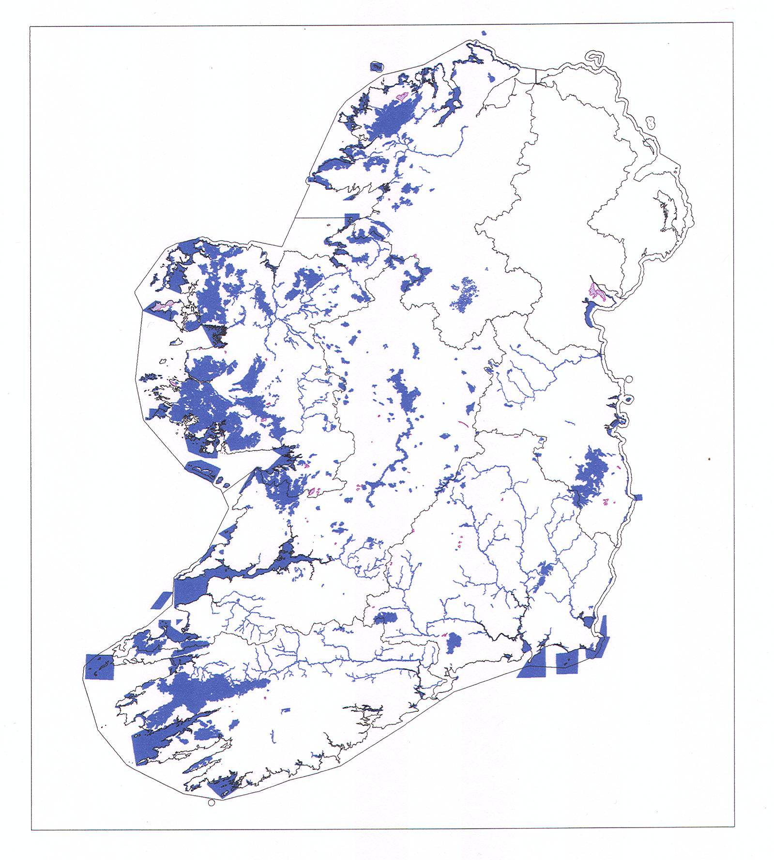
Figure 1. Register of Protected Areas: SACs. Coastal and onshore SACs listed for water dependent habitats and species as a Qualifying Interest (in blue). RBD boundaries are shown. SACs which do not have water dependent habitats and species as a Qualifying Interest are also shown (in mauve)

The attached database SAC_Water_Dependency includes all 419 coastal and onshore SACs (the four cold water coral reef SACs fall far offshore and thus outside the RBD areas). The Register of Protected Areas includes 363 SACs, i.e. the SACs in which at least one water dependent Annex 1 listed habitat or Annex 2 listed species is listed as a Qualifying Interest.

SACs not currently on the Register of Protected Areas are included in the database, because many of them do have Habitats Directive Annex listed as occurring within them (as non-qualifying interests; listed as P in the database), or include Heritage Council (Fossitt, 2000) water dependent habitats within their boundaries, (see Appendix 1).

Habitats Directive listed water dependent habitats and species are described briefly below, and the pressures impacting upon them are elucidated. The information included is drawn from the backing documentation of the Article 17 conservation status reporting, and focuses on identified pressures (current) and threats (future) to habitats and species that are required to be addressed through water quality and quantity management measures under the Water Framework Directive. The conservation status of each water dependent habitat, and of the associated water dependent species as assessed under Article 17 of the Habitats Directive (for the period 2000 to 2006) is also given in the tables below. The sensitivities of Annex 1 listed habitats and Annex 2 listed species to hydrological and water quality pressures are considered further on Section 5 of this report. The four cold water coral reef SACs are not considered as they fall outside the RBD areas.

3.3. Coastal marine habitats.

Habitat Code | Habitat Name (#) | Structure and functions (Condition) | Overall Conservation Status
1110 | Sandbanks which are slightly covered by sea water all the time (3) | Favourable | Inadequate
1160 | Large shallow inlets and bays (35) | Unknown | Inadequate
1170 | Reefs (52) | Inadequate | Inadequate
8330 | Submerged or partially submerged sea caves (15) | Favourable | Favourable
# Note: The number of SACs in which each habitat occurs as either a Qualifying Interest, or is present, is given in brackets

Coastal marine habitats occur as a Qualifying Interest in 41 SAC sites nationally. Reef habitats include rocky reefs, which occur along some 42% of the coastline. Biogenic reefs (i.e. built up by living organisms, including mussel and oyster beds in inshore waters, and polychaete worms and corals in inshore and offshore waters) are likely to be widely distributed in inshore and offshore waters, but are not yet well known. Sandbanks (Code1110) occur mainly in the Irish Sea, and have an important role in sediment transport and supply to shores along the east coast. The range and area of sea caves are not well known.

The main pressures and threats to coastal marine habitats identified by the Article 17 conservation status assessment were fishing/dredging, extraction, and construction. Water pollution from discharges, and possibly from aquaculture, are potentially impacting some large shallow inlets and bays sites.

There is a risk to partially enclosed inlets and bays from eutrophication. However, it should also be borne in mind that partially enclosed inlets and bays may also host important concentrations of wintering waterfowl that feed mainly within the intertidal habitats associated with the inlet or bay. In these types of sites, there are potential conflicts of nature conservation interests that will need to be carefully addressed in the consideration of water quality standards, and during the consideration of Waste Water Treatment Plant effluent standards, for example.
Sea caves are not well known, these habitats are not thought to be subject to significant adverse impacts, but faunal communities could be impacted by poor water quality.

3.3.1. Water dependent species associated with coastal marine habitats.

Annex II listed animal species which occur in coastal marine habitats are as follows:
Common name (#) | Scientific name | Overall Conservation Status
Grey Seal (40) | Halichoerus grypus | Favourable
Common Seal (32) | Phoca vitulina | Favourable
Bottle-nosed Dolphin (8) | Tursiops truncatus | Favourable
Harbour Porpoise (16) | Phocaena phocaena | Favourable
# Note: The number of SACs in which each species occurs as either a qualifying interest, or is present, is given in brackets

3.4. Coastal transitional habitats.

Habitat Code | Habitat Name (#) | Structure and functions (Condition) | Overall Conservation Status
1310 | Salicornia and other annuals colonising mud and sand (24) | Inadequate | Inadequate
1330 | Atlantic salt meadows (Glauco-Puccinellietalia maritimae) (56) | Inadequate | Inadequate
1410 | Mediterranean salt meadows (Juncetalia maritimi) (44) | Inadequate | Inadequate
1420 | Mediterranean and thermo-Atlantic halophilous scrubs (Sarcocornetea fruticosi) (2) | Inadequate | Bad
1130 | Estuaries (37) | Unknown | Inadequate
1140 | Mudflats and sandflats not covered by sea water at low tide (59) | Inadequate | Inadequate
1150 | *Coastal lagoons (36) | Bad | Bad
Note: # The number of SACs in which each habitat occurs as either a qualifying interest, or is present, is given in brackets. * Priority Annex 1 listed habitats are indicated with * and are bold-faced

Coastal transitional habitats occur as Qualifying Interests in 70 SAC sites nationally.

3.4.1. Coastal lagoons.
Coastal lagoons, a priority listed habitat, are included in this group because although salinity varies, all lagoon water bodies are at least brackish water. A key feature of lagoons is restricted tidal exchange, which makes them vulnerable to eutrophication. A total of 87 lagoon sites are recognised currently, including 100 individual lagoons. The conservation status of each individual lagoon site has been assessed by NPWS (see Figure 2, on the following page).

Five main morphological types of lagoon are recognised:

- Classic "sedimentary" lagoons found on all parts of the coastline (21 lagoons, 41.4% of habitat area), lagoons separated from the sea by a shingle or cobble ridge.
- Artificial lagoons found on all parts of the coastline (30 lagoons, 35.2% of habitat area).
- "Rock/peat" lagoons on the west coast, similar to lagoons in Scotland, but otherwise rare in Europe (18 lagoons, 20% of habitat area).
- "Karst" lagoons are found in parts of Counties Clare, Limerick, and Galway, and within Europe, are possibly unique to Ireland (11 lagoons, 4.5% of habitat area).
- "Saltmarsh" lagoons (6 lagoons, 1.5% of habitat area).

Lagoons depend on a range of water source types, including coastal, transitional, surface water and ground water. The main pressures on lagoon habitats are eutrophication arising from agricultural sources, and from urban waste water discharges and on-site waste water systems, resulting in bad conservation status affecting over 60% of the overall lagoon area including sites located within SACs as a qualifying interest. Drainage and modification of hydrography, including the installation of non-return valves resulting in modification of salinity, are also listed as damaging pressures. A database based on the Article 17 conservation status reporting has been prepared by the Western RBD (attached, and with further notes given in Appendix 9 of this guidance). Notes on coastal lagoon sites where unfavourable status requires measures under the Habitats Directive are included in the coastal lagoons database and also in the SAC_Water_Dependency database.

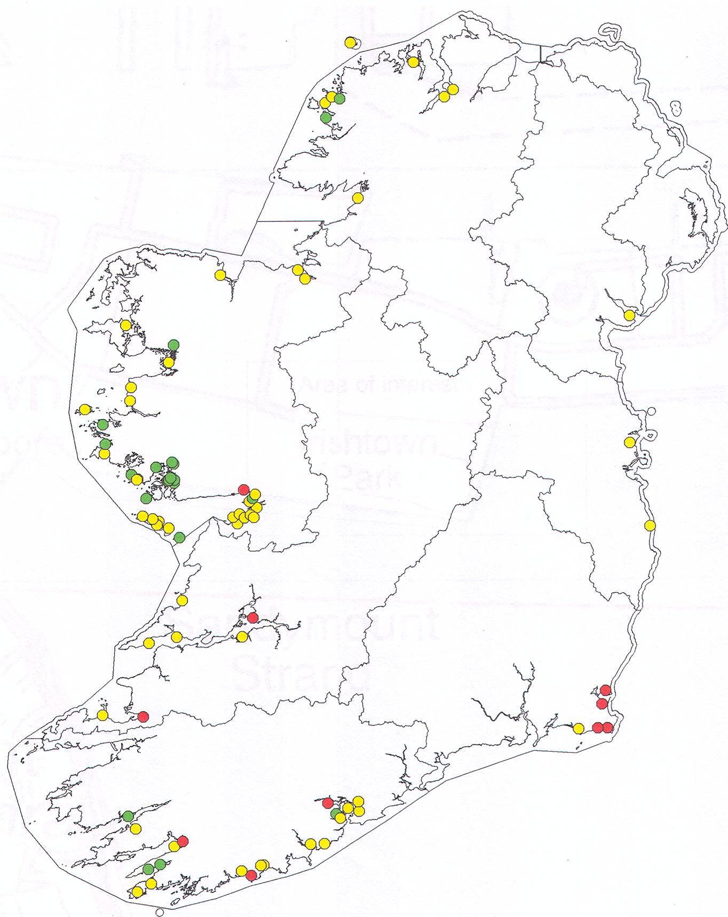

Figure 2. Conservation status of coastal lagoons, 2007.

Colour-coded to represent the 2007 Article 17 Conservation Status assessment: green = favourable, amber = unfavourable-inadequate, red = unfavourable-bad. Grey = unknown.

3.4.2. Intertidal habitats.

Salicornia and other annuals colonising mud and sand (1310), and the three Annex 1 listed salt-meadow habitats (1330, 1410 and 1420), develop in sheltered areas in estuaries and to the lee of islands and other coastal barriers and spits where muddy sediments can accumulate. They occur on the upper shore, and tend to form zones or habitat mosaics of halophytic and salt tolerant plant species in relation to the extent of tidal submergence and salinity. All five habitats are vulnerable to erosion, mobilisation and re-deposition of sediments, and this pressure is likely to increase with climate change impacts including storm surges and rising sea levels. A systematic survey of saltmarsh habitats is in progress for NPWS, and digital mapping will be available on completion of this project (early 2009). Initial indications suggest that most of the adverse impacts to these habitats arise from over-grazing and consequent physical damage to the habitats, with this impact noted more frequently in the west of Ireland. Dumping, land-filling and reclamation have also resulted in loss of saltmarsh habitats. Water quality issues have not been reported to date, however data are not widely available for these habitats.

Estuary (1130) and mudflats and sandflats not covered by sea water at low tide (1140) habitats are located throughout the Irish coastline; Dundalk Bay and the Shannon Estuary are the largest sites nationally which include them. Water quality issues are noted among the adverse pressures on these habitats, and overall conservation status is assessed as inadequate. An NPWS monitoring programme for estuaries is scheduled to commence in 2008.

With regard to water pollution from point and diffuse sources, it is noted that organic particles, nutrients, heavy metals, persistent organic pollutants and dangerous substances tend to deposit with and bind to fine muds in the most sheltered parts of river estuaries and the associated sand and mudflats. Where monitoring of these areas is carried out, it is recommended that a sediment sampling and analysis programme is included, and that sampling sites are chosen to include likely ‘worst case’ scenario pressures.

3.4.3. Water dependent species associated with coastal transitional habitats.

Annex listed mammals associated with coastal transitional habitats are grey seal, common seal (see Section 3.3.1), and otter (see Section 3.6.2.1).

Coastal transitional habitats are used by nationally and internationally important concentrations of wintering waterfowl (divers, grebes, herons, swans, geese, ducks, waders, and gulls). These habitats are also used for feeding by some breeding seabird species, in particular terns, with nesting colonies located on islands and coastal onshore habitats such as shingle banks, and also on man-made structures such as the mooring dolphins in Dublin Port. Most of the important sites are covered by Special Protection Area (SPA) designations under the Birds Directive; the national SPA network is currently under review by NPWS and notifications of updates are on-going.

3.5. Coastal onshore habitats.

Habitat Code | Habitat Name | Structure and functions (Condition) | Overall Conservation Status
1210 | Annual vegetation of drift lines (40) | Favourable | Inadequate
1220 | Perennial vegetation of stony banks (48) | Inadequate | Inadequate
2110 | Embryonic shifting dunes (44) | Inadequate | Inadequate
2120 | Shifting dunes along the shoreline with Ammophila arenaria (“white dunes”) (55) | Bad | Bad
2130 | *Fixed coastal dunes with herbaceous vegetation (“grey dunes”) (52) | Bad | Bad
2140 | *Decalcified fixed dunes with Empetrum nigrum (7) | Bad | Bad
2150 | *Atlantic decalcified fixed dunes (Calluno-Ulicetea) (12) | Bad | Bad
2170 | Dunes with Salix repens ssp. argentea (Salicion arenariae) (14) | Inadequate | Inadequate
2190 | Humid dune slacks (26) | Inadequate | Bad
21A0 | Machairs (*in Ireland) (32) | Bad | Bad

Note #: The number of SACs in which each habitat occurs as either a qualifying interest, or is present, is given in brackets. * Priority Annex 1 listed habitats are indicated with * and are bold-faced. Colour-coded to represent the 2007 Article 17 Conservation Status assessment: green = favourable, amber = unfavourable-inadequate, red = unfavourable-bad.

Coastal onshore habitats occur as a qualifying interest in 73 SAC sites nationally. Annex 1 listed surface water dependent lake habitats also occur in 11 of these sites, and river habitats occur in a further 4 sites. Coastal onshore habitats include dependency on coastal, transitional, surface water and groundwater source types (see Section 5, Table 5.1).

Coastal onshore habitats depend on coastal geomorphological and sediment transport processes for their formation and continued existence, and are highly vulnerable to climate change impacts including increased storm surges and rising sea levels. They have an important current role in coastal protection, and their immediate hinterland often includes low-lying areas of other water dependent habitats such as coastal lagoons (e.g. Lady’s Island Lake and Tacumshin SACs in Wexford), or saltmarsh and fen (e.g. the Murrough Wetlands SAC in Wicklow). In other locations, these coastal onshore habitats protect low-lying hinterland in agricultural, and/or in residential use (e.g. north Dublin). NPWS has recently completed digital habitat mapping of this group of habitats.

Drift line, stony banks and sand dune systems are widely distributed around the Irish coast. Sand dune systems may include wetland habitats Humid dune slacks 2190, and Dunes with Salix repens ssp. argentea (Salicion arenariae) 2170, which occur in topographic depressions in dune systems and are mainly ground water dependent, generally with a lens of fresh water overlying more saline water.

Machair is a distinct geomorphological and ecological habitat that is unique to the exposed Atlantic north-west coasts of Ireland and Scotland. In Ireland, machair occurs from Co. Galway north to Donegal. It develops in exposed conditions where wind erodes an original sand dune system down to a level just above the water table, where the wet consistency of the sand prevents further erosion. Typically, there is a small escarpment or dune ridge along the shore, with the machair plain in its lee, although machair can also develop over coastal rock platforms in the absence of a dune building phase. Typically, there is a lake on the landward side of the machair plain, at the junction of the sand with the underlying bedrock and its associated soils and subsoils. Lake water chemistry in these situations may be influenced by a combination of acidic bed-rock, wind blown sand of marine origin with a significant proportion of shell giving a calcareous influence, and brackish ground water or wind-blown salt giving a saline influence. Machair is a dynamic habitat; as sand moves across the plain, lakes and other wetland habitats such as marsh and fen tend to become infilled, while new wet areas are exposed by erosion of sand down to the water table. Wetlands are thus an integral part of machair habitat, with ground water, surface water, and in some instances transitional water contributing.

For landscape reasons, coastal onshore habitats attract recreational uses including golf courses, sports pitches, and caravan and car park developments, as well as residential development. These lead to hydrological pressures including water abstraction for golf course irrigation and other purposes, reducing groundwater levels, leading to saline intrusions, and impacting adversely on dune slack and machair habitats and on the water dependent plant and animal species associated with them. Reduced water table levels may also make these landforms more vulnerable to erosion. Water quality pressures associated with agricultural fertiliser use, and with domestic and recreational facility waste water, are likely to arise in dune slacks, wetland areas and lakes associated with dune and machair systems – although this has not been investigated by Article 17 monitoring to date, the findings for lagoon and lake habitats suggest that eutrophication is likely to occur in dune and machair wetlands, and may also constitute a risk to groundwater given the permeable nature of the sandy soils present. Groundwater vulnerability is generally extreme in these areas.

It should be noted that the hinterland of coastal onshore habitats often includes shallow soils over relatively impermeable rock, so that nutrients and other pollutants arising from diffuse sources will tend to flow over the bedrock and find their way to lakes and other wetlands within the coastal onshore habitat complex, giving rise to cumulative impacts.

Agricultural improvement and overgrazing are widespread in dune and machair systems, but while they are the most widespread source of adverse impacts on these habitats reported in the conservation status assessments, they are considered reversible through the agreement and implementation of sustainable grazing levels under NPWS Conservation Plans and REPS schemes.

Water status pressures leading to unfavourable conservation status in individual coastal onshore habitats within SACs arise from ground water abstraction, and eutrophication (see Appendix 8, and the SAC_Water_Dependency database). Pressures on water dependent species associated with coastal onshore habitats are discussed in Section 3.5.1 below.

3.5.1. Water dependent species associated with coastal onshore habitats.

Common name (#) | Scientific name | Main pressures and threats
Petalwort (20) | Petalophyllum ralfsii | Water abstraction
Narrow mouthed whorl snail (18) | Vertigo angustior | Adverse hydrology, eutrophication, pesticides

Petalwort Petalophyllum ralfsii
Petalophyllum ralfsii is a small thalloid liverwort, and is usually found on damp, calcareous sand in dune slacks and machair, where it is wet or even subject to inundation in the winter. In dune slacks it often occurs in a zone around the margins of seasonally flooded basins or depressions. In machair it is usually found around the sides of eroding sand hills on open, flushed sandy plains. P. ralfsii often seems to favour the sides of paths or wheel ruts where the soil receives some disturbance, leading to gaps in the vegetation. It does not grow in slacks that are water-filled for long periods, or which are heavily shaded. It usually disappears from view when the substrate dries out in the summer, surviving as tubers. It can vary in apparent abundance from year to year, depending on weather conditions. P. ralfsii occurs as a Qualifying Interest in 20 SACs in Ireland; the entire national range is protected.

Because of the fragility of its habitat and its specialised ecology, P. ralfsii is potentially threatened by a large number of factors, including holiday developments, recreational activities, under-grazing, over-grazing, erosion and desiccation due to water abstraction. Its conservation status is currently assessed as favourable. The main threat identified arises in relation to groundwater abstraction.

Narrow-mouthed whorl snail Vertigo angustior
The narrow-mouthed whorl snail Vertigo angustior is listed as a qualifying interest in 13 SACs and occurs in 5 further SACs. Most sites for this species are in sand dune systems along the western seaboard, it survives at only two inland sites: Pollardstown Fen and Ryewater Valley/Cartron SACs in Cos. Kildare and Meath, and has been recorded recently for the first time in fen habitat in Curraghchase Woods in Co. Limerick (Site Code 00174).

In Ireland Vertigo angustior is found associated with decaying vegetation in the litter layer, or in damp moss, in association with permanently moist but free-draining (permeable) soil, not subject to inundation. It is the latter requirement that makes seemingly suitable and widespread habitat unable to sustain a population of V. angustior. It can tolerate salt spray and brief submersion by high water spring tides.
Vertigo angustior is sensitive to modification of site hydrology which affects ground-water or surface water, eutrophication including exposure to agricultural run-off giving rise to changes in plant community structure; application of pesticides (including herbicides). Exposure to leisure activities, especially on coastal sites, can have serious negative impact on V. angustior populations e.g. installation of caravan parks, marina development (on estuaries), motor vehicles/sports. Introduction of shrubs, e.g. sea buckthorn Hippophae rhamnoides, can also be a problem on coastal sites.

In Ireland, the main loss of Vertigo angustior sites appears to be a result of loss of riverside and canal-side habitat, exploitation of esker sites and drainage of local wetlands or more extensive areas, and sheep grazing and over exploitation of dune sites. Its conservation status is currently assessed as unfavourable – inadequate. A 3-year monitoring programme for all Vertigo sites is in progress for NPWS, with annual updates on distribution and a final report due in December 2010. The main threat identified arises in relation to groundwater abstraction.

3.6. Surface water dependent habitats.

Habitat Code | Habitat Name | Structure and functions (Condition) | Overall Conservation Status
3110 | Oligotrophic waters containing very few minerals of sandy plains (Littorelletalia uniflorae) (52) | Bad | Bad
3130 | Oligotrophic to mesotrophic standing waters with vegetation of the Littorelletea uniflorae and/or of the Isoëto-Nanojuncetea (26) | Bad | Bad
3140 | Hard oligo-mesotrophic waters with benthic vegetation of Chara spp. (26) | Bad | Bad
3150 | Natural eutrophic lakes with Magnopotamion or Hydrocharition-type vegetation (11) | Unknown | Bad
3160 | Natural dystrophic lakes and ponds (18) | Bad | Bad
3260 | Watercourses of plain to montane levels with the Ranunculion fluitantis and Callitricho-Batrachion vegetation (26) | Bad | Bad
3270 | Rivers with muddy banks with Chenopodion rubri p.p. and Bidention p.p. vegetation (1) | Favourable | Favourable
6430 | Hydrophilous tall herb fringe communities of plains and of the montane to alpine levels (19) | Inadequate | Inadequate
91E0 | *Alluvial forests with Alnus glutinosa and Fraxinus excelsior (Alno-padion, Alnion incanae, Salicion albae) (50) | Bad | Bad
Note #: The number of SACs in which each habitat occurs as either a qualifying interest, or is present, is given in brackets. * Priority Annex 1 listed habitats are indicated with * and are bold-faced.
Colour-coded to represent the 2007 Article 17 Conservation Status assessment: green = favourable, amber = unfavourable-inadequate, red = unfavourable-bad. Grey = unknown.

Surface water dependent habitats occur as a qualifying interest in 87 SACs. It should be noted that three of the habitat types included in this group also have a significant groundwater dependency as follows:

- 3140 Hard oligo-mesotrophic waters with benthic vegetation of Chara spp.
- 3270 Rivers with muddy banks with Chenopodion rubri p.p. and Bidention p.p. vegetation
- 91E0 *Alluvial forests with Alnus glutinosa and Fraxinus excelsior
(Alno-padion, Alnion incanae, Salicion albae)

Rivers generally are groundwater dependent to a varying degree, particularly at low flows.

3.6.1. Lake habitats 3110, 3130, 3140, 3150, 3160.

The Article 17 Conservation Status Assessment Report for lake habitats indicates that substantial work remains to be done in elucidating Habitats Directive Annex 1 lake types in Ireland. The detailed distribution and characteristics of the different Annex 1 lake habitats are not well documented currently. Notwithstanding this difficulty, the conservation status of Annex 1 lake habitats, in the context of the national resource including lakes within and outside the Natura 2000 network of Protected Areas, has been assessed as uniformly bad. The Annex 1 listed lake habitats are naturally oligotrophic, with the exception of 3150_natural eutrophic lakes which can be regarded as mesotrophic in EPA terminology.

NPWS is currently planning lake survey work, originally scheduled to commence in 2009 but now deferred to 2010 because of budgetary and staff resource constraints. These surveys will focus on defining the resource based on biotic communities (algae, other plants, invertebrates and fish) and will link the communities described to the WFD lake typology. NPWS considers that further refinement of the Habitats Directive Annex 1 listed lake habitat types, which are based mainly on macrophyte communities, is necessary in order to produce a meaningful conservation classification system for Irish lakes. The NPWS lake survey project will also design and initiate a monitoring programme to assess the conservation status of the relevant Annex 1 lake habitats.

It should be noted that some of the Habitats Directive Annex 1 listed lake habitats are highly oligotrophic (3110, 3140, 3160). Where WFD lake status has been downgraded because of evidence of unfavourable conservation status under the Habitats Directive, and this is related to water quality pressures, it is important to ensure that high status environmental quality standards are applied as a measure to restore favourable conservation status. It is possible that for some Annex 1 listed lake habitats, high status environmental quality standards may not be stringent enough for the protection of highly oligotrophic lakes. Lake survey work by NPWS should be accompanied by investigative monitoring of water quality in order to clarify these issues and ensure that appropriate standards are applied so that favourable conservation status is restored.

For example, the Water Framework Directive requires water chemistry monitoring which may not indicate any exceedance of relevant water quality standards for a particular lake. Habitats Directive biotic and macrophyte community monitoring of the same lake may indicate adverse impacts on community structure, or on the abundance of more sensitive species (for example some of the Charophyte species in lake habitat 3140_ Hard oligo-mesotrophic waters with benthic vegetation of Chara spp), which could be explained by lake bed sediment loadings of Phosphorus. Where these kinds of discrepancies arise, it is important that the results of monitoring programmes carried out under different legislation are compared, and monitoring protocols and/or WFD ecological status assessment adjusted, to ensure that the causes of unfavourable conservation status under the Habitats Directive are fully understood, and additional remedial measures are put in place. The Lough Carra/Mask Complex SAC (Site Code 001774) is an example of a lake complex where sediment monitoring would be recommended to help elucidate observed pressures on Habitats Directive Annex 1 listed qualifying interests.

The threats and pressures identified in the Article 17 conservation status assessments for Annex 1 listed lake habitats are listed below. The reporting procedure for these assessments follows a standard format of reporting impacts and activities affecting habitats and species (see Appendix 5), and is not accompanied by water quality monitoring; EPA water quality data are referred to. Pressures relate to current activities, and threats relate to likely future activities expected to give rise to pressures. Eutrophication, acidification, direct impacts on habitats, and the presence of alien species are the main pressures and threats identified. Hydrological pressures on lakes and their associated habitats and species arising from abstraction may be under-reported in Article 17 assessments, although a number of specific instances are noted in Appendix 8.

Lake type | 3110 - 3130 -3140 | 3150 | 3160
Main pressures | 120 Fertilisation  140 Grazing  160 General Forestry management  310 Peat Extraction  700 Pollution  954 Invasive species | 120 Fertilisation  140 Grazing  160 General Forestry management  700 Pollution  954 Invasive species | 140 Grazing  150 Restructuring agricultural land holding  160 General Forestry management  180 Burning  310 Peat Extraction  311 Hand-cutting of peat  312 Mechanical removal of peat  810 Drainage
Threats | 120 Fertilisation  140 Grazing  160 General Forestry management  310 Peat Extraction  403 Dispersed habitation  600 Sport and leisure structures  700 Pollution  954 Invasive species | 120 Fertilisation  140 Grazing  160 General Forestry management  403 Dispersed habitation  600 Sport and leisure structures  700 Pollution  954 Invasive species | 140 Grazing  150 Restructuring agricultural land holding  160 General Forestry management  180 Burning  312 Mechanical removal of peat  810 Drainage

Note that the dystrophic lake type 3160 can arise artificially because of anthropogenic impacts on 3110 and 3130 lake types, principally from afforestation on blanket bog and wet heath within the catchment, resulting in high colour and low pH (3-6) and consequent loss of 3110/3130 plant communities. The natural pH range for dystrophic lakes is 3-6.

The Draft European Communities Environmental Objectives (Surface Water) Regulations (2008) provide a framework within which the more stringent environmental requirements of the Habitats Directive can be addressed, although it should be noted that resource issues arise in meeting the timescales envisaged for the clarification of WFD ecological status versus HD conservation status issues.

A number of individual lakes within SACs, which are currently assessed by NPWS as being at unfavourable conservation status, are identified in the SAC_Water_Dependency database, and in Appendix 8 of this guidance.

3.6.1.1. Protected species occurring in lake habitats.

Najas flexilis.

Common name | Scientific name | Main pressures and threats
Slender Naiad (25) | Najas flexilis | Eutrophication, acidification
The number of SACs in which Najas flexilis occurs as either a qualifying interest, or is present, is given in brackets.

The Annex II listed plant slender naiad Najas flexilis occurs in lakes that are transitional between hard water and soft water types. It has been recorded in a total of 49 lakes, and continues to be present in 36 lakes, with three known extinctions, and 10 sites at which its status is uncertain. It occurs in 25 SACs, and is listed as a Qualifying Interest in 24 of them. Najas is a small annual plant, and population size can vary substantially between years; because of this, uncertain status can not be taken as proof of extinction currently, but indicates that further surveys should be informed by assessment of risks and pressures. Conservation status is assessed as favourable in 29 lakes, 8 of which are not covered by a nature conservation designation currently. The species occurs in Donegal, Leitrim, Mayo, Galway and Kerry. Connemara in west Galway appears to be the species Irish stronghold with 25 of the 49 recorded populations occurring there. Eutrophication from agriculture and dispersed habitation are the main pressures/threats; acidification is also a threat. The full site list and details for Najas flexilis is held by NPWS. A database summarising these details is attached to this guidance (see Appendix 10 for the definition table); lake water bodies requiring measures under the Habitats Directive for Najas are identified in this and in the SAC_Water_Dependency database (see Figure 3 below).

The conservation status assessment backing documentation drew attention to Ballynakill Lough (SEG_CD 32_479) as being among the 30 lakes at favourable conservation status for Najas flexilis, but also as having a particularly diverse aquatic flora with a number of rare species. Comments like these which arise from individual species surveys are useful in identifying water bodies likely to be close to reference condition, which may merit high status listing under the Water Framework Directive with associated protective measures, and the creation of new or the extension of existing conservation designation boundaries to cover an appropriate area including and around them.

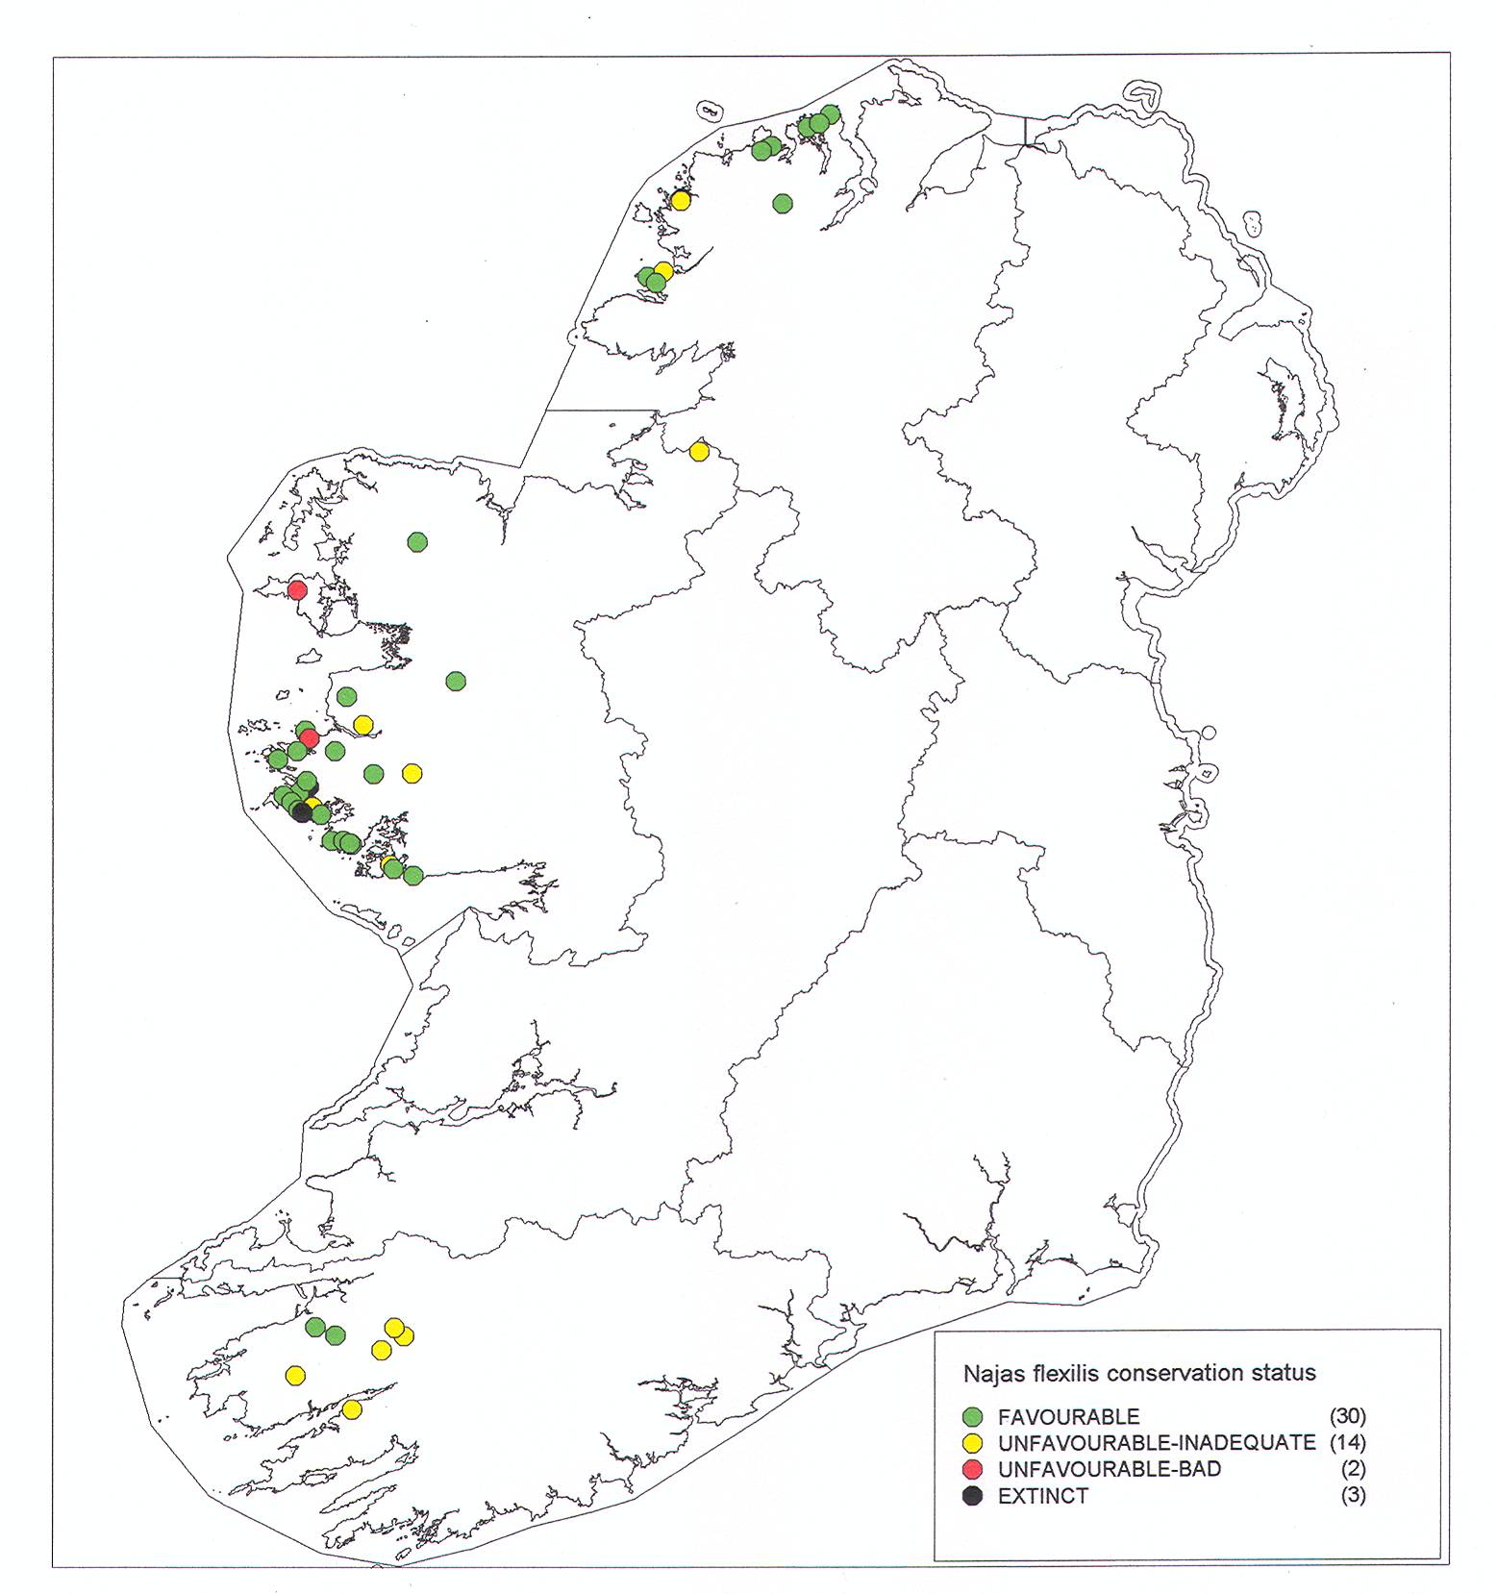
Figure 3. Conservation status of the Habitats Directive Annex 2 listed plant species Najas flexilis, which currently occurs in 46 lakes.

Annex II listed species otters, fish and crayfish make use of lake habitats, but are considered under river habitat 3260 below. The freshwater pearl mussel Margaritifera margaritifera also occurs in some lakes

3.6.1.2. Arctic char.
Arctic char are not listed in Annexes to the Habitats Directive, but have been included as a water dependent species because of their threatened status, high lake water quality requirement and hence usefulness as an indicator species, and vulnerability to water abstraction. Their presence is an indicative element of high lake water body ecological status. They are very vulnerable to eutrophication. Spawning and nursery areas used by Arctic char are located in shallow lake margins, and these are vulnerable if low water levels coincide with the spawning and early development stages of the fish, impacting on the extent of spawning habitat available and also on invertebrate prey. Abstraction related structures including impoundments and dams can also permanently block access by Arctic char and other fish species, including the Habitats Directive Annex 2 listed (in freshwater only) salmon.

Data provided by the Irish Char Conservation Group for current char lakes have been linked to EPA water body codes by the Western RBD; this database includes information on current threats and pressures and is attached to this guidance (see Appendix 11 for the definition table).

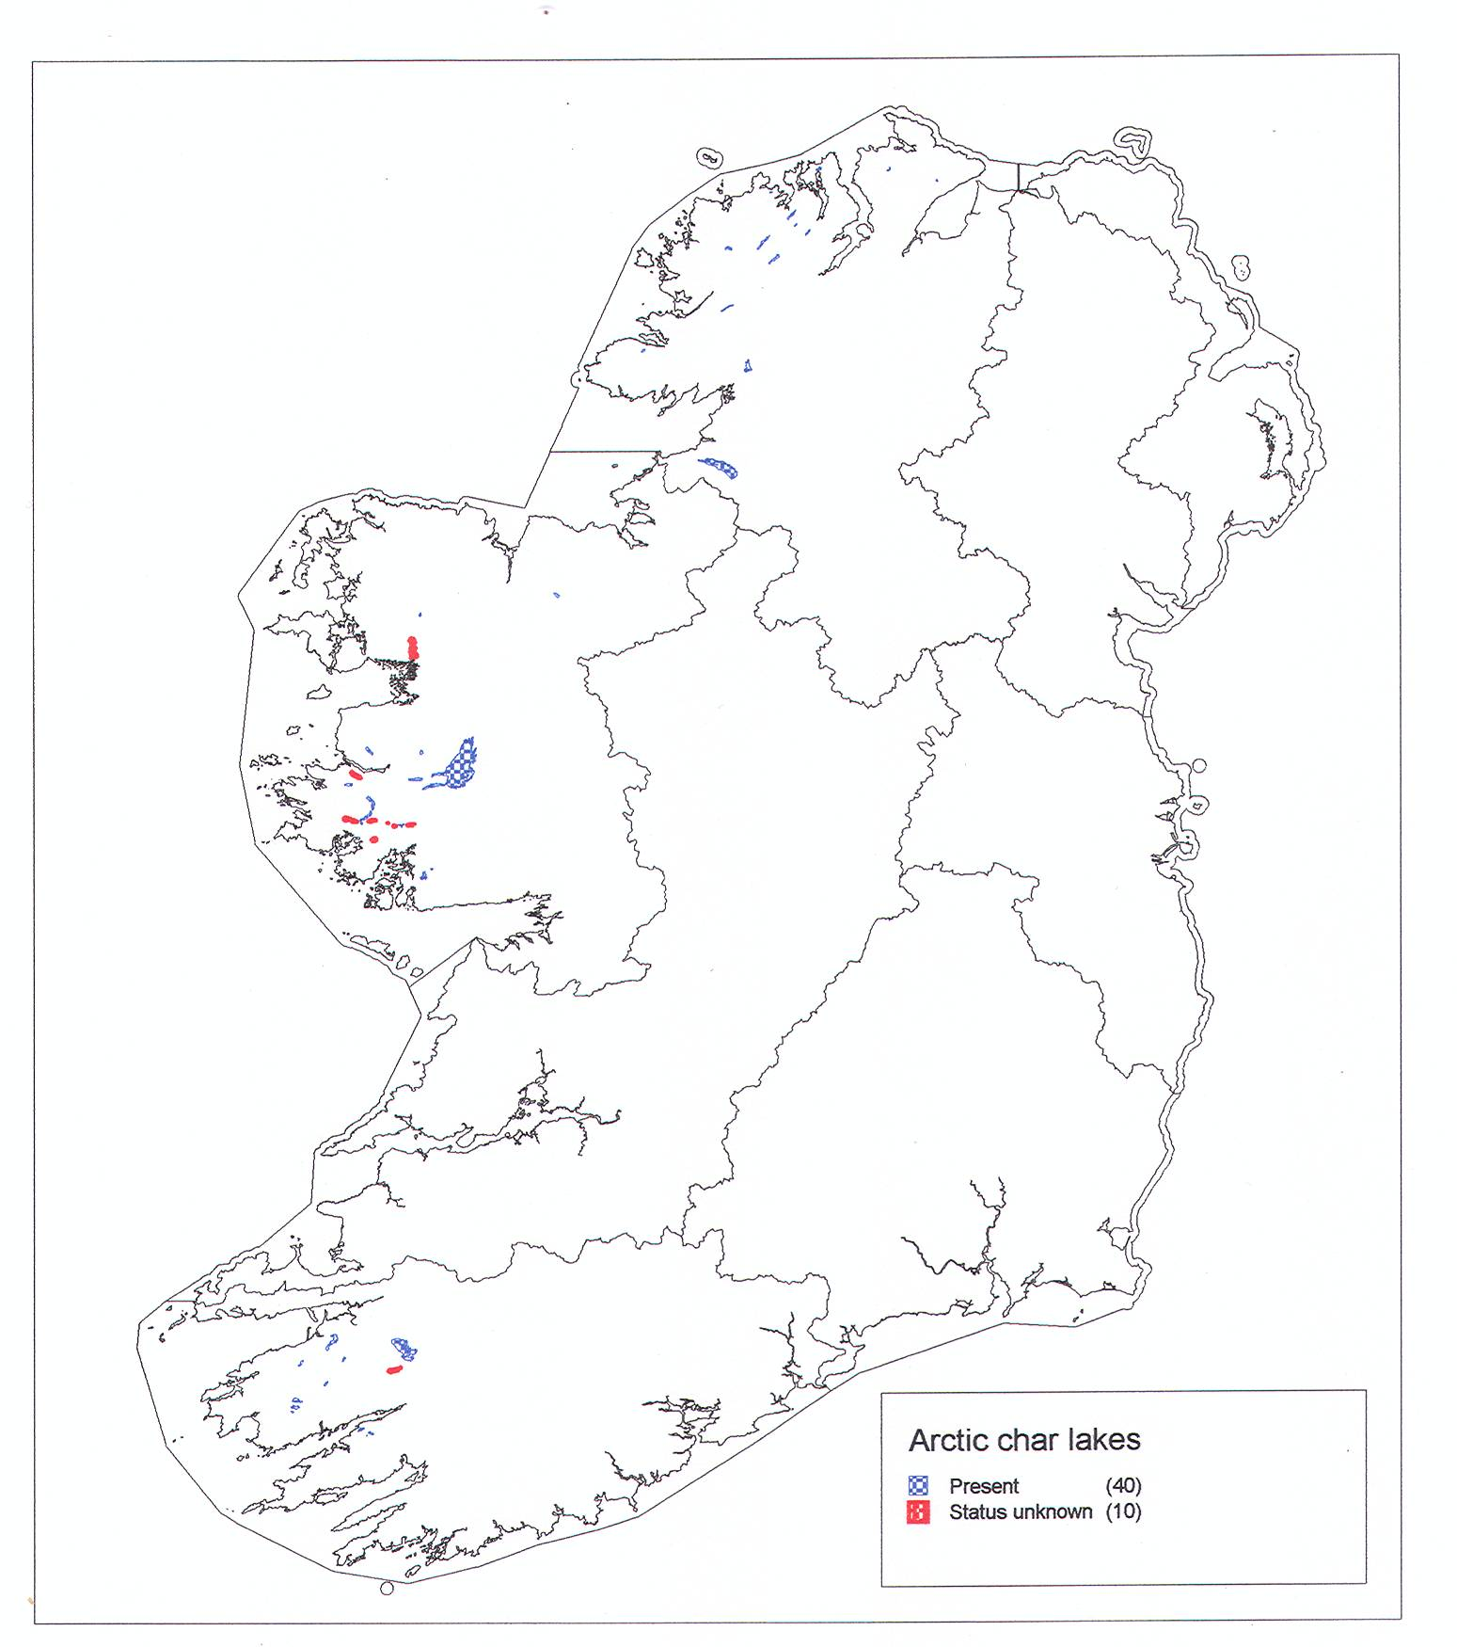
Figure 4. Current distribution of Arctic char in Ireland.

3.6.2. River and associated habitats

3260: Watercourses of plain to montane levels with the Ranunculion fluitantis and Callitricho-Batrachion vegetation
The overall area of this habitat is based on all rivers. High gradient channels where the typical vegetation communities of 3260 do not occur, have been included for Fontinalis (a moss species) dominated communities. River habitat 3260 is listed as a qualifying interest in 21 SACs and is listed as present in a further 5 SACs. Information on the structure and functions, and on overall conservation status, is taken from EPA monitoring results and WFD risk assessments, and indicates bad conservation status as regards the overall national resource. Conservation status assessments are not currently available for the individual SAC qualifying rivers. A survey of Annex 1 listed river habitats by NPWS is expected to start in 2009.

The Unshin River SAC in Co. Sligo is among the better known rivers in terms of existing ecological data, although this dates mainly from the 1990s. This largely un-drained system flows across several geological boundaries between sandstone, shales and limestone, resulting in unusual physico-chemical qualities. The Unshin is regarded as exceptionally diverse for both aquatic and channel margin macrophytes, and has un-modified lowland sections which are unique in Ireland and almost unknown elsewhere in Europe. It requires WFD high status and a Q value of 4-5 to 5 to maintain it at favourable conservation status

The main pressures and threats to river habitat type 3260 are assessed as arising from eutrophication from point and diffuse sources, forestry related pressures, and hydrological change. Siltation is a significant ecological pressure, although this pollutant has not been subject to the same level of investigation as other parameters of water quality and has tended to be under-reported. The sensitivities of individual rivers are related to the presence of sensitive Annex 2 listed water dependent fauna (see Section 3.6.2.1 below).

3270 - Rivers with muddy banks with Chenopodion rubri p.p. and Bidention p.p. vegetation
In Ireland, this water dependent habitat is associated principally with turloughs, where it occurs in damp, nutrient-rich soils subject to flooding and where the vegetation is dominated by annual plants. It thus occurs mainly in riverine turloughs which are naturally eutrophic, and is associated with livestock trampling and dunging which add to the waterborne nutrients. The habitat also occurs sporadically on the beds of reservoirs, for example at the Gearagh in Co. Cork. The extent of this habitat fluctuates from year to year in relation to flooding/drying out. Its conservation status is favourable. Only one SAC site is specifically listed for this habitat currently, however it does occur as a vegetation community within sites listed for other qualifying interests, notably turloughs. WFD good status measures are thought to be sufficient to protect this habitat in rivers.

91E0 *Alluvial forests with Alnus glutinosa and Fraxinus excelsior

(Alno-padion, Alnion incanae, Salicion albae)
The remaining native broadleaved woodlands are very fragmented in Ireland, and invasive non-native species are often present, leading to some difficulties in defining woodlands which conform to the 91E0 habitat classification. A broad approach has been taken in the conservation status assessment; alluvial forests are defined as occurring in areas subject to periodic flooding along rivers, and along lake shores. Three alluvial forest variations are recognised: alder/ash riparian woodland on alluvial soils, riparian alluvial willow woodland which may also include oak and ash, and alluvial willow alder woodland beside lakes, which can also include black poplar.

Alluvial forests flood from river and lake water, but most sites are also subject to ground water inputs and marginal springs are often present, they are thus vulnerable to hydrological pressures including groundwater abstractions.

Drainage ditches within and around the boundaries of alluvial woodland areas have been recorded in 46% of sites, and drain removal/blocking has been recommended by NPWS as a management measure. Arterial drainage schemes and other hydrological alterations have resulted in a reduction in the incidence and duration of flooding in some sites.

6430 Hydrophilous tall herb fringe communities of plains and of the montane to alpine levels
This habitat occurs along the margins of watercourses and is dominated by herbs, and is not well described in Ireland. It is included within the scope of a national grassland survey that has been initiated by NPWS and which will elucidate the extent of, and variation within the habitat. The main threats and pressures to this habitat are identified in the conservation status assessment as drainage and river channel maintenance works, dykes and embankments which limit the occurrence of the habitat, and invasion by alien species especially Himalayan balsam Impatiens glandulifera.

3.6.2.1. Annex II listed species of river channels.

A number of Annex II listed water dependent species of fauna occur in river channels, both within SACs as Qualifying Interests, within SACs but not noted as a Qualifying Interest, and outside the current conservation site designation network:

Common name (#) | Scientific name | Main pressures and threats
Otter (140) | Lutra lutra | Terrestrial and aquatic habitat loss, pollution, disturbance, road fatalites
River Lamprey (10) | Lampetra fluviatilis | In-stream works
Brook Lamprey (16) | Lampetra planeri | In-stream works
Sea Lamprey (11) | Petromyzon marinus | River channel obstruction; weirs, in-stream works
Atlantic Salmon (freshwater only) (61) | Salmo salar | Eutrophication, forestry related pressures, siltation
Allis Shad (5) | Alosa alosa | River channel obstruction; weirs, eutrophication, fisheries (by-catch)
Twaite Shad (8) | Alosa fallax fallax | River channel obstruction; weirs, eutrophication, fisheries (by-catch)
White-clawed Crayfish (22) | Austropotamobius pallipes | Point discharges, siltation  alien species
Freshwater Pearl-mussel (28) | Margaritifera margaritifera | Loss of Q5+ water quality, siltation
Nore freshwater pearl mussel (1) | Margaritiefera durrovensis | Loss of Q5+ water quality, siltation

Note: Annex II listed fauna species, colour-coded to represent the 2007 Article 17 Conservation Status assessment: green = favourable, amber = unfavourable-inadequate, red = unfavourable-bad. Grey = unknown.
#: The number of SACs in which each species occurs as either a qualifying interest, or is present, is given in brackets

Where present in rivers, freshwater pearl mussels are the most sensitive receptors in terms of water quality and status, and this Section provides summary information for these species. Further details for all Annex 2 listed river species can be found on www.npws.ie

Fresh water pearl mussel Margaritifera species.
Readers are referred to the Article 17 conservation status backing documentation for Margaritifera margaritifera and M. durrovensis for detailed descriptions of both species, the pressures and threats identified for them, and how they operate on these now very highly threatened species. All populations are at unfavourable-bad conservation status, mainly because of continuous failure to produce new generations of mussels because of the loss of clean gravel beds in rivers. Gravels have become infiltrated by fine sediment and/or overgrown by biofilm (including bacteria, fungi, benthic microalgae (including diatoms) and microfauna), filamentous green algae (macroalgae), or macrophytes. All of these block the required levels of oxygen from reaching juvenile mussels, which spend the first 5 – 10 years buried within the river bed substrate.

The freshwater pearl mussel M. margaritifera lives in oligotrophic, acid to neutral waters of rivers flowing over granite or sandstone rock, mainly in the western part of Ireland, but also in areas of the south and south east where geological conditions allow. The ecology of the species is particularly notable in that individuals can grow to very large sizes relative to other freshwater molluscs, building up thick calcareous valves, in rivers that have soft water with low levels of calcium. Their shell building is consequently very slow, and individuals in natural conditions live to over a hundred years of age. M. margaritifera requires stable cobble and gravel substrate with very little fine material below pea-sized gravel. Adult mussels are two-thirds buried and juveniles up to 5-10 years old are totally buried within the substrate. The lack of fine material in the river bed substrate allows for free water exchange between the open river and the water within the substrate. The free exchange of water means that oxygen levels within the substrate do not fall below those of the open water. This is essential for juvenile recruitment, as this species requires continuous high oxygen levels.

There are 93 known surviving populations of M. margaritifera in Ireland. This species is listed as a qualifying interest in 19 SACs, with several qualifying populations in some of them. It is recognised by NPWS however, that further survey work is required to check and confirm the current range, particularly for the populations that have not been listed as qualifying interests and which lie at least partly in a further 9 SACs. This work is ongoing as part of a rapid assessment survey for the species, which also includes assessment of recoverability of juvenile habitat.

The Nore freshwater pearl mussel Margaritifera durrovensis does not live in acid waters like M. margaritifera. It is currently only known only from the lime-rich waters of the River Nore. The Nore population stretches from Poorman’s Bridge (S 407 859) to Lismaine Bridge(S 442 660), with most of the population found between Poorman’s Bridge and the Avonmore Creamery above Ballyragget (S 440 722). Margaritifera durrovensis is critically endangered both globally and in Ireland (Moorkens 2006a). For a species to have a chance of survival, a single population is not enough. The aim, therefore, is to introduce a second population to at least one other river to give the species a better chance of survival. A captive breeding programme is underway (since 2005) to aid this process, but has, to date, met with little success. Surveys are also ongoing to identify suitable translocation sites within the wider Nore catchment, however none have yet been found.

Improving the conservation status of the two fresh water pearl mussel species represents a considerable challenge, as both species are critically dependent on high water status. Management planning and measures are considered in Sections 5 and 7 of this guidance.

3.7. Ground water dependent habitats.

Habitat Code | Habitat Name | Structure and functions (Condition) | Overall Conservation Status
3180 | *Turloughs (51) | Inadequate | Inadequate
7220 | *Petrifying springs with tufa formation (Cratoneurion) (25) | Bad | Bad
7210 | *Calcareous fens with Cladium mariscus and species of the Caricion davallianae (45) | Bad | Bad
7230 | Alkaline fens (64) | Bad | Bad
8310 | Caves not open to the public (15) | Favourable | Favourable
Note #: The number of SACs in which each habitat occurs as either a qualifying interest, or is present, is given in brackets. * Priority Annex 1 listed habitats are indicated with * and are bold-faced

The groundwater dependent habitats listed above occur as a qualifying interest in 103 SAC sites nationally.

3180: Turloughs.
Turloughs can be defined as topographic depressions in karst limestone, which flood intermittently and mainly from groundwater. Most turloughs occur in areas of thin glacial drift, in gentle relief on well-bedded, pure, grey calcerenite, that has a greater degree of karstification than other limestones as a result of its purity and well-developed bedding. All turloughs are characterised by the fact that they chiefly flood and drain via connections with groundwater, such as springs, swallow-holes and estavelles, they can also be associated with sinking rivers. They occur in a variety of settings, including among limestone pavement (a), and as part of a landscape mosaic of esker ridges, turloughs and raised bogs in parts of Cos. Galway and Roscommon (b), for example (see below).

(a) Turloughs in the East Burren Complex SAC, Co Clare  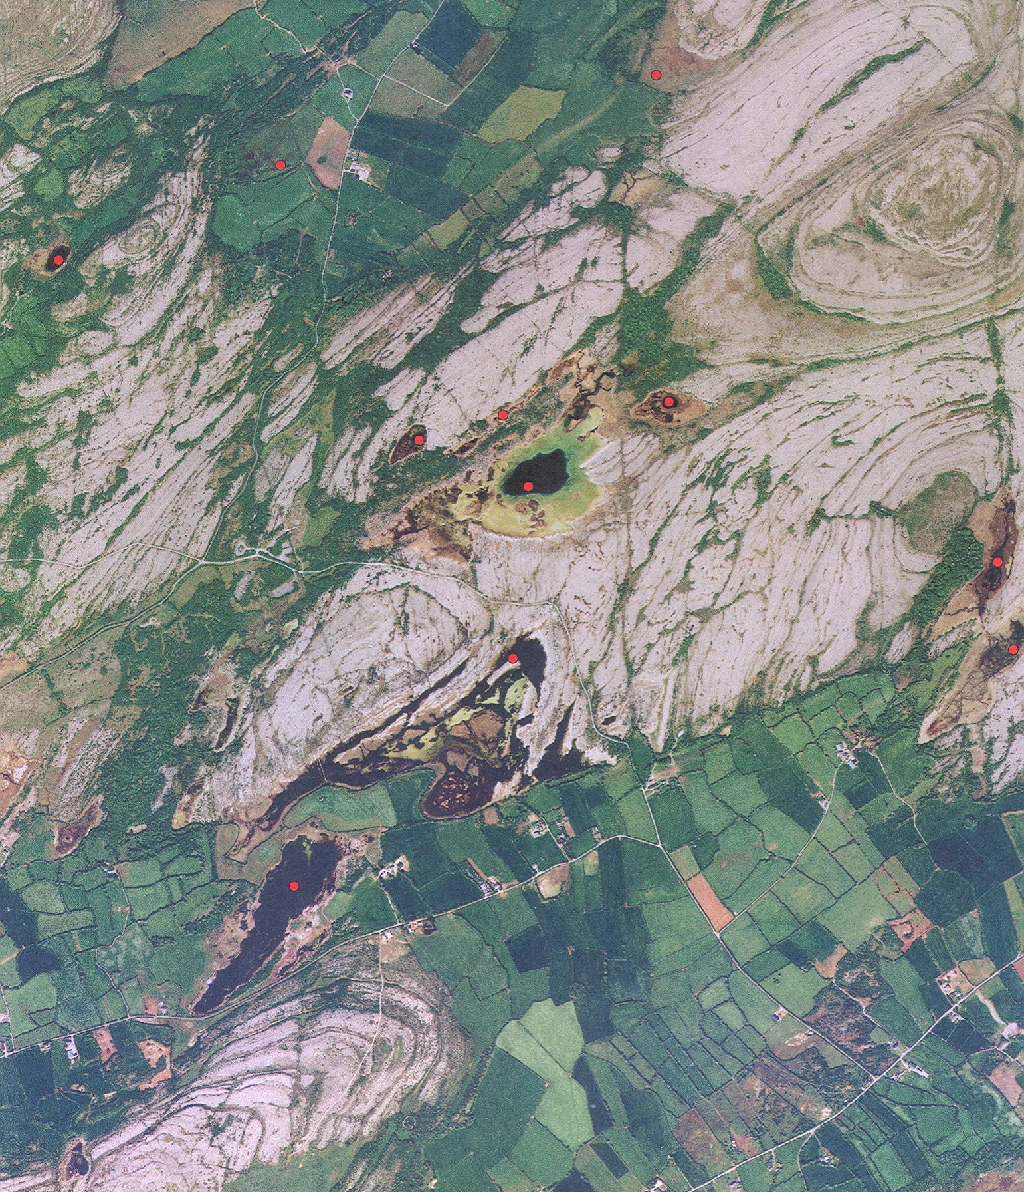  Includes Ordnance Survey of Ireland data  reproduced under OSI license No.  2003/07CCMA/Galway Co. Council | 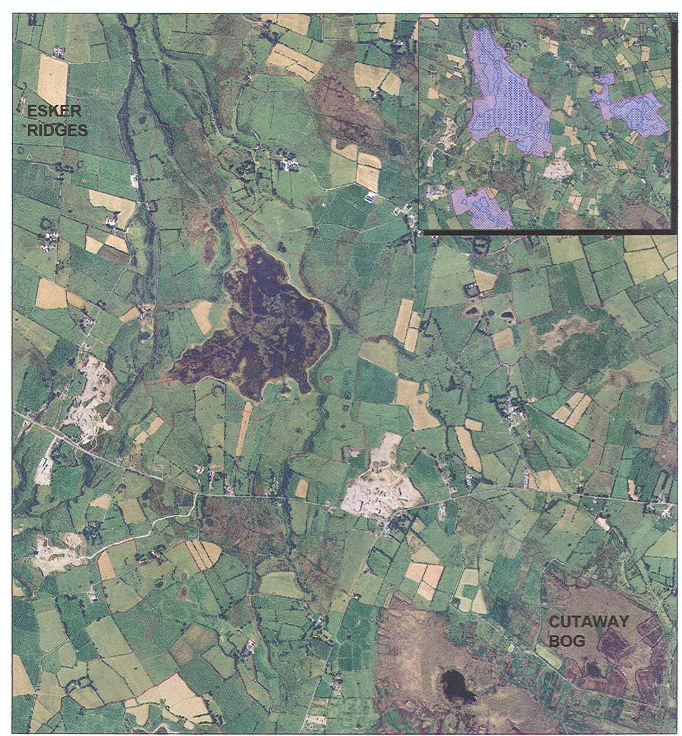  (b) Coolcam Turlough SAC, Croaghill Turlough SAC, and part of Williamstown Turloughs SAC, set among eskers and remnants of raised bogs in Galway/Roscommon. All are included in the Shannon RBD; however the Williamstown turloughs appear to be hydrologically linked to the WRBD (ECS, 1997)  Includes Ordnance Survey of Ireland data  reproduced under OSI license No. 2003/07CCMA/  Galway Co. Council
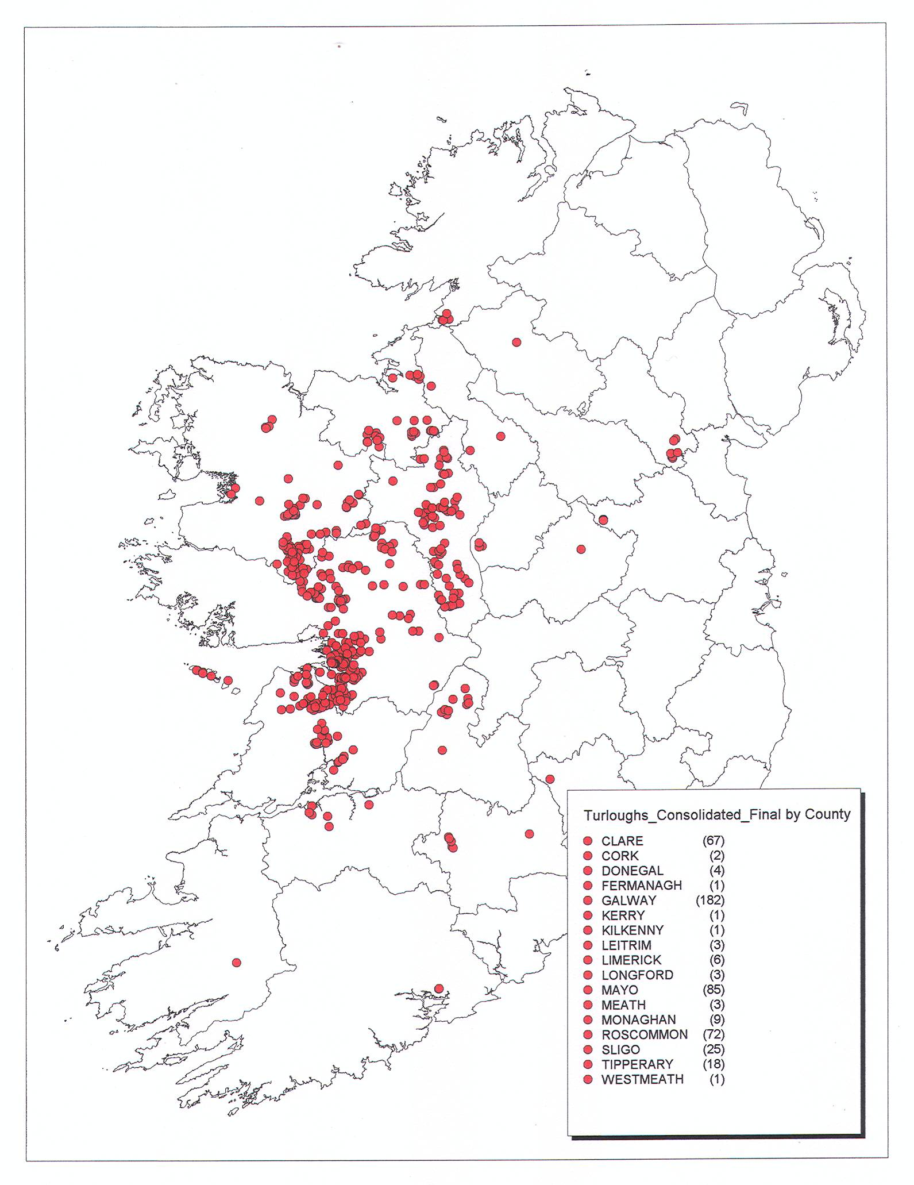
The currently known distribution of turloughs in Ireland. The total number of sites (483) in the Turloughs Consolidated Database (16.11.2008), includes 3 duplicate point locations for individual site complexes, and one site which is also listed as a Coastal karst Lagoon. The number of individual confirmed turloughs, and possible/probable turloughs is 477-479.

Turlough typology relates to the type of karst flow at individual turlough sites. Conduit flow turloughs (Type 1) are typically associated with high volume and velocity systems, a large catchment area, and have a relatively high natural trophic status i.e. mesotrophic. Type 2 turloughs are associated with shallow epikarst flow, with low volume and velocity, a relatively small catchment area, and are typically oligotrophic. There are intermediate examples of turloughs which exhibit both types of karst flow. Some turloughs also have surface water inflow and outflow, for example Rahasane in Co. Galway. Some also receive distributed flow from sediments, such as esker ridges. In reality, it is likely to be difficult to assign individual turloughs to any one typology. Turlough ecology varies in relation to hydrology and hydrochemistry, and also in relation to agricultural and other land use practices within the turlough basin, on the adjoining sloping land above flood level, as well as within the groundwater catchment area. A number of studies are currently in progress (see Kilroy and Dunne, 2008, for examples and bibliography)

A consolidated turlough database including previously known and newly identified turlough sites is currently available as a draft database (dated 16.11.2008) from NPWS on request. A consultation version will be available on the GSI website in the near future. It should be noted that the database provides point locations within turlough basins, and that individual turlough basins vary substantially in size. EPA mapped lake water bodies (sometimes more than one) occurring within turlough basins as permanent (though varying in size) and/or as seasonal lakes, are cross-referenced in the turlough database by SEG_CD code. NPWS also holds some mapped polygons for turloughs.

With regard to the Water Framework Directive, a key feature of turloughs is that the turlough basin is in direct contact with groundwater. Activities within and adjoining the basin thus constitute a risk to groundwater.

7220: Petrifying springs with tufa formation.
Petrifying springs are permanently irrigated and kept moist by groundwater that is calcareous and oligotrophic in nature. The water supply is from upwelling groundwater sources, including shallow groundwater seepage sources, or sometimes deep groundwater geo-thermal sources. Petrifying springs may be closely associated with alkaline fens but with less fluctuations in water table (Curtis et al 2006). A key requirement is a steady flow of water, though this may dry up periodically. Petrifying springs can be broadly separated into permanent flow and intermittent flow springs.
Springs are often very small features covering no more than some tens of meters. Petrifying springs occur on shallow peaty or skeletal mineral soils.
On contact with the atmosphere at the spring head, carbon dioxide is lost from the water or is depleted by photosynthetic activities of plants growing in the spring, which results in the precipitation of a calcium carbonate tufa. The vegetation in such areas, and especially mosses may be coated in a thick crust of lime. Larger petrifying springs may form tufa cones that constitute a singular habitat.
Petrifying springs occur in lowland and upland areas and may be associated with a variety of different habitats such as alkaline fen, woodland, heathland, grassland, limestone rich boulder clay or gravel deposits or on exposed rock. Spring vegetation is characterized by an abundant or dominant moss cover and may or may not be peat-forming.
NPWS holds a database of petrifying springs, but it should be noted that there are some difficulties with the accuracy of point locations (see Sections 4 and 7).

7210: Calcareous fens with Cladium mariscus and species of the Caricion davallianae (Cladium fens)
Cladium fens are characteristic of flat ground and not of slopes. This habitat is subject to smaller fluctuations in tater table than alkaline fen. Cladium fen is more calcareous and oligotrophic than alkaline fen (Curtis et al 2006). In Ireland Cladium fens occur in a variety of situations including topogenous fens found in valleys or depressions, floodplains, over-grown-ditches, in flats and depressions, extensive wet meadows, within tall reed beds, on the landward side of lakeshore communities, calcium rich flush areas in blanket bogs, dune slack areas, fens adjacent to raised and blanket bogs, in turlough sites and wet hollows in machair often in association with alkaline fen.

7230: Alkaline fen
Fens are usually peat-forming wetlands that receive minerals (magnesium, iron, and in particular calcium) from sources other than precipitation: usually from upgradient sources through drainage from surrounding mineral soils and from groundwater movement. In general they are poor in nitrogen and phosphorus, the latter of which tends to be the limiting nutrient in fen systems. Although fens can be found as discrete wetland habitats in their own right, they often also occur in association with (or as a mosaic within) a range of other water dependent habitats including blanket bog, raised bog, turlough, dune slack, machair, wet heathland, wet grassland, woodland, karst areas, lacustrine and riverine habitats and systems.
NPWS holds a database of alkaline fens, but it should be noted that there are some difficulties with the accuracy of point locations, and there are few mapped polygons currently (see Sections 4 and 7).

Threats and pressures identified in Conservation Status Assessments for turloughs, petrifying springs, Cladium fens and alkaline fens are shown below. All are highly vulnerable to hydrological pressures, including water abstractions, arterial drainage, local drainage, and infilling. Water quality issues also arise, and individual sites can be expected to vary considerably in their buffering capacity for nutrient loadings. Refer also to groundwater support issues for precipitation dependent habitats in Section 3.8.

 | 7220: Petrifying springs | 7210 Cladium fen | 7230 Alkaline fen | 3180 Turlough
Main current pressures and future threats | 140 Overgrazing  150 Restructuring agricultural land holding  310 Peat Extraction  800 Landfill, land reclamation and drying out, general  803 Infilling ditches, dykes, ponds, marshes and pits  810 Drainage  890 Other human induced changes in hydraulic conditions | 140 Overgrazing  150 Restructuring agricultural land holding  161 Forestry Planting  310 Peat Extraction  311 Hand-cutting of peat  312 Mechanical removal of peat  701 Water pollution  800 Landfill, land reclamation and drying out, general  803 Infilling ditches, dykes, ponds, marshes and pits  810 Drainage | 140 Overgrazing  150 Restructuring agricultural land holding  161 Forestry Planting  310 Peat Extraction  311 Hand-cutting of peat  312 Mechanical removal of peat  701 Water pollution  800 Landfill, land reclamation and drying out, general  803 Infilling ditches, dykes, ponds, marshes and pits  810 Drainage | 810 Drainage  148 Overgrazing  709 Eutrophication  311 Peat cutting and marl extraction  301 Quarrying  403 Dispersed habitation

3.7.1 Protected and Annex 2 listed species associated with ground water dependent habitats.

Common name (#) | Scientific name | Main pressures and threats
Geyer’s whorl snail | Vertigo geyeri (15) | Hydrological pressures, land use pressures
Desmoulin’s snail | Vertigo moulinsiana (9) | Drying out of habitat, land use and hydrological pressures
Yellow marsh saxifrage | Saxifraga hirculus (6) | Land use pressures
Slender green feather-moss | Hamatocaulis vernicosus (8) | Land use pressures including eutrophication
Lesser horseshoe bat | Rhinolophus hipposideros (47) | Hydrological pressures on cave hibernation roosts
The number of SACs in which each species occurs as either a qualifying interest, or is present, is given in brackets. Note that lesser horseshoe bats are not formally listed as water dependent, and are listed in the SAC Water Dependency database only in SACs where there are hibernation roosts in caves

Geyer’s whorl snail Vertigo geyeri
Vertigo geyeri occurs as a Qualifying Interest in 14 SACs, and is also known to be present in the River Moy SAC. It occurs in saturated water conditions in calcareous, ground water fed flushes that are often limited in size to a few metres square. These habitats are generally found in mosaics of suitable patches within wider fen macro-habitats, which in Ireland can themselves fall within wider site habitats that can be as diverse as raised bog laggs, transition mires, lake shores, hill or mountain slopes, and wetlands associated with coastal dunes and machair. It lives within the saturated and decaying roots of small sedges (particularly Carex viridula ssp. brachyrrhyncha), and associated fen mosses (particularly Drepanocladus revolvens and Campyllium stellatum).

In Ireland, localised extinctions of Vertigo geyeri have been a direct result of drainage of wetlands in the Midlands. At sites where the species is in low numbers, particular attention needs to be paid to whether hydrological or management changes have taken place, and to pressures on the wider catchment or water body supporting the hydrology of the small patches of suitable habitat where the snails occur. A basic requirement for this species is the maintenance of a favourable hydrological regime, so management practices that alter site hydrology or hydrogeology (whether ground water or surface water are affected) can be very damaging to it. Favourable hydrological conditions include saturated ground, and spring flow with network of dendritic trickles (as opposed to channelled overground flow from a spring).

Nutrient enrichment arising from local land use, whether from agricultural run-off, use of fertilisers (including organic manures) or slurry spreading, or dunging by grazing animals, can also be damaging, as would be pesticide use (including herbicides). Sheep-dip run-off would be especially damaging.

Management prescriptions have been prepared by NPWS for land use issues for all SAC populations, wider issues such as abstractions and other hydrological impacts will require WFD measures under the Habitats Directive. A 3-year monitoring programme for all Vertigo geyeri sites is in progress for NPWS, with annual updates on distribution and a final report due in December 2010. Vertigo geyeri is also monitored on an on-going basis as an indicator species at Pollardstown Fen SAC.

Desmoulin’s whorl snail Vertigo moulinsiana
Vertigo moulinsiana occurs as a qualifying interest in 7 SACs, and is present in a further 2. It mainly inhabits calcareous, lowland wetlands: in swamps, fens and marshes usually bordering rivers, canals, lakes and ponds where very humid conditions prevail, often enhanced by open water evaporation during the spring to autumn. Its habitats include surface and ground water dependent features.

Vertigo moulinsiana lives on both living and dead stems and leaves of tall plants: grasses including reeds (e.g. Glyceria maxima, Phragmites australis), and sedges (e.g. Carex riparia and Cladium mariscus. As well as the tall vegetation structure of the habitats above, V. moulinsiana requires a stable hydrology, where the water-table is at, or slightly above, the ground surface for much of the year, and any seasonal flooding is of very low amplitude. It climbs tall vegetation in the summer and autumn, and in winter it descends to litter level, and in severe conditions aestivates on the lower leaves of plants.

The range of Vertigo moulinsiana has become smaller in recent years than it was in former times, when habitat for the species was widespread along the major river flood plains. It is likely that this habitat began to experience losses when large-scale modification became widespread. With the building of the canals towards the end of the 18th Century, a new set of habitat corridors became available to the species, and most of the modern populations for the snail are within sites that are likely to have been colonised from the canal corridors: fens, ditches and lake margins. Some of its sites are transitional in nature in that they are inclined to dry out progressively, as well as being at risk through direct anthropogenic activity. Monitoring and maintenance of water levels are important to on-going conservation of this species. A 3-year monitoring programme for all Vertigo sites is in progress for NPWS, with annual updates on distribution and a final report due in December 2010.

Yellow marsh saxifrage Saxifraga hirculus.
Saxifraga hirculus occurs as a Qualifying Interest in 5 SACs, and is present in one further SAC, all in Co. Mayo. In Ireland, this plant now appears to be restricted to mineral flushes in what is otherwise ombrotrophic blanket bog, occurring in small areas of ground water dependent poor fen and non-calcareous spring habitats (Fossitt habitat types, 2000), which occur within precipitation dependent habitat. S. hirculus was previously recorded from a number of midland counties in Ireland namely Tipperary, Westmeath, Offaly and Laois, but these raised bog sites have been lost due to drainage and peat removal. S. hirculus is currently found only in County Mayo with eight sites documented (NPWS). A number of additional sites adjacent to an existing documented site were observed in May 2004 and another new site identified in the summer of 2006. All known populations lie within 5 of the Irish national 10km grid squares, these are indicated on the NPWS website public map viewer, and more detailed locational data can be requested from NPWS. All populations lie within SACs, except for one recently discovered population near the Owenpollaphuca River to the east of Glenamoy Bog Complex SAC (000500). All populations are assessed as being at favourable conservation status currently; the main threats to Saxifraga hirculus are from land use pressures, e.g. grazing, drainage and windfarm construction. However, hydrological pressure from ground water abstractions would be damaging.

Slender green feather-moss Hamatocaulis (Drepancladus) vernicosus.
H. vernicosus is present as a Qualifying Interest in 8 SACs. It is characteristic of mires that are mineral-rich but not strongly calcareous. It is strictly confined to relatively base-poor fen, a transitional habitat between acid bog and base-rich fen. This appears to occur in at least two forms in Ireland: upland transitional flushes and wet lowland sedge meadows. Land use pressures including enrichment from agricultural sources are potential threats at lowland sites. Water abstraction and other hydrological change, and groundwater enrichment are potential risks. All populations are assessed as being at favourable conservation status currently.

Information on threatened bryophytes in Ireland, including H. vernicosus, is being compiled by NPWS as part of a project towards a bryophyte Red Data Book for Ireland, which has been running since 1999 and is due for completion in 2010. This has entailed collation of existing data and new fieldwork, and is resulting in a database of threatened bryophytes, from which distribution maps will be produced. Most historical sites for H. vernicosus have been visited, and all will have been visited within the next two years. In addition some new sites have been discovered. All known populations are within the SAC network.

Rhinolophus hipposideros
Lesser horseshoe bats have been included as a water dependent species in SACs where there are hibernation roosts in caves, which may be vulnerable to flooding. It occurs as a qualifying interest in 41 SACs, and is present in a further 6 SACs. The only cave roost known to have been adversely affected by flooding in the past is Kiltartan Cave SAC (Site Code 000286), during high flood events in 1994/95. Water status issues arise only for cave roosts. Lesser horseshoe bats are currently listed at favourable conservation status, and are not regarded as water dependent by NPWS; they are included for information only as it currently seems unlikely that WFD management measures arise for this species.

3.8. Precipitation dependent habitats.

Habitat Code | Habitat Name | Structure and functions (Condition) | Overall Conservation Status
4010 | Northern Atlantic wet heaths with Erica tetralix (67) | Bad | Bad
7110 | *Active raised bogs (60) | Bad | Bad
7120 | Degraded raised bogs still capable of natural regeneration (66) | Inadequate | Inadequate
7130 | Blanket bog (*if active bog) (71) | Inadequate | Bad
7140 | Transition mires and quaking bogs (29) | Bad | Bad
7150 | Depressions on peat substrates of the Rhynchosporion (72) | Favourable | Favourable
91D0 | *Bog woodland (21) | Inadequate | Inadequate
Note #: The number of SACs in which each habitat occurs as either a qualifying interest, or is present, is given in brackets. * Priority Annex 1 listed habitats are indicated with * and are bold-faced

Precipitation dependent habitats occur as a qualifying interest in 124 SACs nationally. These habitats all include groundwater dependent elements, or depend on groundwater support (discussed for each individual habitat below), but are retained as a separate habitat grouping because the principal land cover within them is generally precipitation dependent (ombotrophic). Damage to these habitats arises through land use pressures including drainage, burning (in an attempt to increase grass cover for livestock grazing), overgrazing, peat cutting, and afforestation. These land uses, either separately or in combination, tend to lead to erosion and loss of capacity to retain water, resulting in adverse impacts and pressures in watercourses in, and downstream of, wet heath and bog habitat areas. These include reduced low flows, increased peak flows and erosion potential in downstream watercourses, increased suspended solids loads, acidification and nutrient loadings arising from afforestation and forestry activities, and increased flood risk. Measures for wet heath and bog habitats, and for forestry, are therefore important for habitat protection and restoration, as well as for the management of downstream impacts. It should be noted that watercourses downstream of wet heath and blanket bog SACs may contain populations of Margaritifera margaritifera, which are identified as requiring measures under the Habitats Directive.

Northern Atlantic Wet Heath (4010) occurs in uplands throughout Ireland, and on lowland areas in the west of Ireland. It occurs on relatively shallow peats (30 – 80 cm), where there can be a slightly fluctuating water table rather than permanently waterlogged peat (more or less permanent water-logging is necessary for peat formation). It can occur in extensive areas, as a habitat mosaic with blanket bog, and can also develop as a secondary wet heath in previously cutover or disturbed areas of both blanket and raised bog.

Drainage, land reclamation, over-grazing by sheep, afforestation, and burning are the main pressures and threats to wet heath habitat. Ground water dependent poor fen habitats within wet heath are vulnerable to hydrological pressures including groundwater abstraction.

Raised bogs (7110, 7120) were abundant in the lowlands of central and mid-west Ireland, but most sites have been lost or severely damaged, in the first instance mainly by peat extraction. In Ireland raised bogs are confined to areas with an annual rainfall below 1250 mm. In areas of higher rainfall, raised bogs are replaced by blanket bog. Raised bog occur principally in land below 130m and are most extensive and abundant where the limestone plain is covered by a variable thickness of undulating glacial drift which originally provided suitable basins for the development of lakes and/or fens, which in turn acted as precursors to the bogs. The raised dome develops as peat formation extends the development of the bog above the level of ground water influence. Intact active raised bog is now extremely rare; and has declined by over 35% in extent in the last 10 years. Deterioration of the raised bog hydrology at current rates caused by peat cutting, drainage, forestry and burning seriously threatens the viability of the habitat. At some sites, restoration works and projects are showing positive results.

There is a direct groundwater contribution to the lagg portion of raised bog habitats, and the bog in general is supported by groundwater, making raised bogs vulnerable to arterial drainage, localised drainage, and groundwater abstraction. If present, these pressures lower the groundwater level under the bog, and reduce the groundwater contribution to the marginal lagg or the raised bog, allowing precipitation derived bog water to seep out of the bottom of the bog.

Blanket bog (7130) occurs along the Atlantic coast of Ireland on lowlands and uplands on slopes of up to c. 25 degrees, and on mountains in the rest of the country. Three types are recognised: lowland, highland, and mountain blanket bog, based on variation in the plant communities present. Areas flushed by mineral groundwater within blanket bog generally correspond to the Heritage Council habitat PF2 poor fen and flush, although Habitats Directive Annex 1 listed fen types can also occur. Many river catchments have their headwaters in blanket bog areas.

Extensive areas of blanket bog have been removed or highly modified, chiefly through reclamation, peat extraction, over-grazing, burning and afforestation, but also via erosion/landslides triggered by anthropogenic factors. Even though impacts have reduced substantially in recent years, agriculture, peat extraction, afforestation, wind farms and other infra-structural developments etc are still causing damage. Impacts from certain activities continue even after the damaging activity has ceased. Drought and extreme weather events predicted as a result of climate change are likely to increase erosion and blanket bog landslides, particularly on poorly vegetated areas, with consequent impacts on water quality in catchments within and downstream of bog areas. Local abstractions of, or discharges to, groundwater pose threats to groundwater associated flush and poor fen communities within blanket bogs.

Depressions on peat substrates of the Rhynchosporion (7150) habitat is associated with raised bog in the lowlands of central and midwest Ireland, and with lowland blanket bog and wet heath in western Ireland. The habitat becomes rare above 300m. The overall habitat conservation status assessment is favourable, despite the unfavourable assessment given to the associated habitats where it is found (e.g. raised bog, blanket bog and wet heath). This is mainly related to the pioneer and transitional nature of the habitat, and its capacity to develop in areas of damaged and degraded bog and wet heath .

Transition mire and quaking bog (7140) habitats support peat-forming vegetation that is transitional between acid bog and alkaline fens, in which the surface conditions range from markedly acidic to slightly base-rich. Individual sites will generally depend to some extent on groundwater, as well as precipitation, and possibly surface water. The vegetation normally has intimate mixtures of species considered to be acidophile and others thought of as calciphile or basophile. Transition mire and quaking bog can develop as a result of soligenous flow, but in most situations there is thought to be a direct groundwater contribution, providing hydrological support and minerals to the habitat and its vegetation.
In some cases the mire occupies a physically transitional location between bog and fen vegetation, as for example on the marginal lagg of raised bog or associated with certain valley and basin mires.
In other cases these intermediate properties may reflect the actual process of succession, as peat accumulates in groundwater-fed fen or open water to produce rainwater-fed bog isolated from groundwater influence. Many of these systems are very unstable underfoot and can therefore also be described as ‘quaking bogs’ or a floating scraw.
Drainage, land reclamation, peat cutting, afforestation, water pollution, dumping, and changes in hydrological conditions in particular groundwater abstractions, are the main pressures and threats causing damage to transition mire and quaking bog habitats.

Bog woodland (91D0) occurs on raised bog, with some sites on transition mire. It is typically dominated by birch trees, with a ground flora of Sphagnum mosses, and is actively peat forming. This habitat is sensitive to activities causing lowering of the water table such as drainage, peat cutting or afforestation.

3.9. Other water dependent habitats.

Vegetated sea cliffs of the Atlantic and Baltic coasts (1230) occur throughout the coast, with rocky cliffs mainly in the west and south-west, and soft cliffs mainly on the east and south-east coasts. This habitat occurs in a total of 48 SACs, and as a qualifying interest in 28, most of which are rocky cliffs with important sea bird breeding colonies. Soft cliffs are vulnerable to erosion by the sea, erosion rates can be increased by coastal protection works on site and at a distance. Recreational uses are also cited as pressures. Development near cliff tops could result in increased/enriched water seepage down the cliff face. The overall conservation status assessment is unfavourable-inadequate.

This habitat has been considered separately from coastal transitional and onshore habitats because it differs from the more mobile soft shores of salt marsh, sand dune and machair, and is not exposed to the same type of land use pressures.

Molinia meadows on calcareous, peaty or clayey-silt-laden soils (Molinion caeruleae) (6410) occur in 46 SACs and are present as a qualifying interest in 14 of them. This habitat is widespread but localised, and is associated with a fluctuating water table, often with seasonal flooding, and generally but not exclusively on acid soils. It often occurs as a mosaic with fen meadow. It is vulnerable to drainage and agricultural improvement, but also to abandonment of farmland and scrub encroachment. The overall conservation status assessment is unfavourable-bad.

3.9.1. Other water dependent species.

Killarney Fern Trichomanes speciosum

Killarney Fern Trichomanes speciosum is extremely sensitive to desiccation, and is not adapted to control water loss. It is confined to deeply shaded, humid habits near cascades and waterfalls in dripping caves, in cliff crevices, in vertical wooded ravines, and occasionally on the floor of damp woodland. It occurs in its sporophyte form as a Qualifying Interest in 18 SACs. It also occurs in its gametophyte form in a number of additional SACs, for which it is not a qualifying interest. The species also occurs in some pNHAs. A total of 67 populations is known, precise locational data are not published because of the history of loss of this species to plant collectors; any queries should be addressed directly to NPWS. The species is vulnerable to hydrological pressures and water pollution, as well as to direct habitat disturbance. The conservation status of Killarney Fern Trichomanes speciosum is assessed as favourable.

4. WATER DEPENDENT HABITATS AND SPECIES: SPATIAL DATA.

Much of the spatial habitat and species data held by NPWS is in transition between paper copy and GIS, with a number of projects on individual or groups of water dependent habitats and species in progress. Because of this, there is still a lack of detailed GIS spatial data on the occurrence of water dependent habitats and species, both inside the SAC network and other in other conservation designations, and in the wider countryside. It is not possible to indicate likely release dates for individual GIS databases; but habitat data will generally be released as polygons. Point locations for some habitats may be released as interim databases pending detailed survey to define habitat boundaries and associated polygons, for example turloughs and fens (see below).

4.1. Database availability from NPWS

Webservices are being further developed by NPWS, through which GIS data are released. Currently designated site boundaries (SAC, SPA, NHA and pNHA) are available as GIS downloads from www.npws.ie . Updates are notified regularly by NPWS, and are available in downloadable GIS files. To subscribe to the NPWS data mailing list, contact NPWS_GIS@environ.ie or robert.ovington@environ.ie
Site synopses, which describe the habitats and species of conservation interest in individual SACs, SPAs and NHAs are also available on the NPWS website.

Currently designated site boundaries (SAC, SPA, NHA and pNHA) and some species data (protected and nationally rare species) are available through an online map viewer (www.npws.ie/en/Maps&Data ). Habitat spatial data are not available online currently.

A consolidated turlough database including previously known and newly identified turlough sites has been compiled, and is currently available as a draft database from NPWS on request. A consultation version will be available on the GSI website in the near future. It should be noted that the database provides point locations within turlough basins, and that individual turlough basins vary substantially in size. EPA mapped lake water bodies (sometimes more than one) occurring within turlough basins as permanent (though varying in size) and/or as seasonal lakes, are cross-referenced in the turlough database by SEG_CD code. NPWS holds some mapped polygons for turloughs.

Indicative habitat mapping (as pdf files) is available at www.npws.ie for those SACs and SPAs for which Conservation Plans have been prepared (see Appendix 6 for a list). National distribution maps on a 10km square basis are available for Annex 1 listed habitats and Annex 2 listed species, at: http://www.npws.ie/en/PublicationsLiterature/HabitatsDirectivereport07/Habitats/
http://www.npws.ie/en/PublicationsLiterature/HabitatsDirectivereport07/Species/

NPWS will maintain and distribute species location and designated site boundary data through the website map viewer. In addition species datasets will be lodged with NBDC and be available through their map-viewer www.biodiversityireland.ie

Species location and habitat data (boundary or point) for ‘water dependent’ species and habitats will be lodged with the EPA and (subject to EPA agreement) made available as layers through ENVision. In addition the information can be made available to WISE map viewer (EEA) and SEIS (EEA) when they come online.

Second tier ‘Shadow lists’ of water dependent habitats and species will be developed and maintained, and will include rare and protected habitats and species listed on National Legislation (Wildlife Act, 1976, and its numerous regulations and orders [e.g. SI 112/1990; 282/1980]; Wildlife (Amendment) Act, 2000; Whale Fisheries Act 1937 and extensions [158/1937; 240/1982]) and national/regional IUCN red lists.

Habitat data is currently only available by lodging a data request with NPWS, however NPWS owned datasets will be made available, with relevant metadata and quality rating information, on the online map viewer as soon as possible.

Staff resources in NPWS, in the biodiversity informatics and GIS areas, are very limited and will not be able to circulate static datasets such as that provided with this report. Users should access the available online ‘live’ systems to ensure they are using the most current datasets.

4.2. Databases circulated by the Western RBD

The following national databases have been developed by the Western RBD in consultation with NPWS, for the use of agencies involved in implementing the Water Framework Directive, and are circulated with this report:

1. SAC_Water_Dependency: GIS SAC map layer, and database listing of all Habitats Directive Annex 1 listed coastal and onshore water dependent habitats, and Annex 2 listed species presence, and presence as a Qualifying Interest, within the SAC network. This database uses the NPWS Habitats Assignment Database dated February 8th 2008, updated with the most recently available information from the Article 17 assessment databases and backing documentation for the following species: Hamatocaulis (Drepanocladus) vernicosus, Najas flexilis, Saxifraga hirculus, Vertigo angustior, Vertigo geyeri, Vertigo moulinsiana, and Margaritifera margaritifera, in consultation with NPWS. The database map layer uses the SAC update notified by NPWS on 4th September 2008.

The SAC_ Water_ Dependency database updates the Register of Protected Areas for the SAC component of the Natura 2000 network, via the logical field WD_H_S = “T”

It should be noted that the boundaries of existing conservation sites are subject to revision, and that additional sites are likely to be proposed for designation under EU and/or national legislation. The map layer provided with the SAC water dependency database should therefore be cross-checked against the most recent GIS releases of SACs by NPWS, both visually and with reference to the boundary version data provided in the browser. It should also be noted that Habitats Directive Annex 1 listed habitats and Annex 2 listed species are subject to on-going survey by NPWS, and the Qualifying Interests listed for individual SACs are revised from time to time, as well as the habitats and species that are present in the SAC as non-qualifying interests.

The definition table for the SAC water dependency database is given in Appendix 4.

2. NPWS databases, linked to EPA water body codes by the Western RBD, with site-specific conservation status assessments:
- Coastal lagoons (priority Annex 1 listed habitat)
- Najas flexilis (Annex 2 listed plant species of lakes)

3. Arctic char lakes, linked to EPA lake water body codes by the Western RBD, with notes on current pressures, as a fish species requiring high water quality and vulnerable to water abstraction impacts: data provided by the Irish Char Conservation Group.

5. WATER STATUS SENSITIVITY OF WATER DEPENDENT HABITATS AND SPECIES.

This Section considers the sensitivity of Habitats Directive Annex 1 and 2 listed water dependent habitats and species to water status management issues that arise under the Water Framework Directive. Ideally, it would be possible to set detailed targets and environmental quality standards for individual catchments on the basis of the most sensitive water dependent habitat and species receptors present, taking hydrological and water quality requirements into account. At present, however, there is not enough spatial information available to allow this to be done for all protected water dependent habitats and species.

The two Habitats Directive Annex 2 listed fresh water pearl mussel species Margaritifera have been identified as particularly sensitive to water status, and all Irish populations are at unfavourable conservation status and require WFD remedial measures under the Habitats Directive. Margaritifera margaritifera and Margaritifera durrovensis will be subject to sub-basin plans under the Water Framework Directive, which will apply to the sole remaining population of M. durrovensis and to 27 Qualifying populations of M. margaritifera. Detailed GIS databases are being prepared for these populations, which will be used in monitoring and audit of the measures which will be applied to them.

Target water quality and habitat attributes for the two fresh water pearl mussel Margaritifera species are included in the backing documentation for the conservation status assessments for these species. Following further consideration by NPWS, objectives for Margaritifera have been published as a Consultation Paper and Draft European Communities Environmental Objectives (Freshwater Pearl Mussel) Regulations by the Minister for the Environment, Heritage and Local Government (December 2008). Following a public consultation phase, and consideration of comments made, the Regulations are expected to be finalised and come into operation in early 2009. The sub-basin plans referred to above will be set up under these Regulations.

There are a number of M. margaritifera populations which are not currently listed as Qualifying populations, but which are nevertheless covered by the legal provisions of the Habitats Directive, and the Wildlife Acts nationally. Survey of these populations is on-going to determine their full extent and status. Listings of the Qualifying and other populations are given in Appendix 7 of this guidance.

With regard to Annex 1 listed water dependent habitats and Annex 2 listed species, a draft report on ecological requirements has been prepared by the North-South Share Project for a total of 18 water dependent habitats and 9 species (Curtis, Downes and Ní Chatháin, 2006), with notes on an additional 4 species. The main difficulty encountered by the authors in compiling the report was the lack of accurate data on physico-chemical water status parameters for conservation sites where the different habitats and species occur within the North-South Share Project area. Most of the available data referred to sites elsewhere in Ireland, and in some cases relevant data is only available from studies carried out within Great Britain. Another difficulty was to determine the precise location from which water or other samples were collected; for example some individual SACs include a very large number of lakes, fens or turloughs, and the annual range of water quality parameters for one of these can not necessarily be assumed to be relevant to another one.

There is a related risk that existing water quality data for a particular water body which is recognised as an Annex 1 listed lake habitat, for example, may be representative of a lake that is not at favourable conservation status under the Habitats Directive; such data should not be used to set Habitats Directive environmental quality standards for that particular lake or for others of the same habitat type. Clearly much work is required to co-ordinate studies and surveys carried out by different agencies so that appropriate data are collected and considered as to their applicability, as measures under the Water Framework Directive are implemented, monitored and audited, and adjusted as Programmes of Measures progress towards the second cycle. Measures intended to address these issues are included in Section 7 of this guidance.

An interim approach.
As outlined above, further elucidation of the water quality/chemistry and water quantity/hydrological requirements of water dependent habitats and species is needed, and this will take time, monitoring effort, and close co-operation between the relevant agencies to develop. In addition there are site specific issues and requirements, particularly for habitats. Current research (as yet unpublished) on turloughs tends to indicate that each of the study sites has unique characteristics, although certain land use and management protocols may well be widely applicable. It is difficult to set targets for water quality/chemistry that will apply across the national range of individual Habitats Directive Annex 1 listed habitats, and it may not be appropriate to set such targets nationally since it is an objective of the Habitats Directive to maintain the range of natural variation; in this sense “one size does not fit all”. The sensitivities of habitats and species are known, however, so it is still possible to identify the most sensitive receptors in a catchment – though the ability to do this will improve as more NPWS GIS data becomes available.

This guidance adopts an interim approach which addresses the general sensitivities of water dependent habitats and species to direct impacts, hydrological impacts, and water pollution. Tables included in this Section indicate the relative sensitivities of habitats (Table 5.1) and species (Table 5.3) to hydrological impacts and water pollution aspects of water status, based on best expert opinion. The tables include comments on issues that should be considered by agencies involved in implementing the Water Framework Directive, when considering existing pressures and risk assessments, and preparing and implementing River Basin Management Plans. These tables are also intended to give guidance on issues that should be considered by Competent Authorities when preparing, or responding to, plans, projects and proposals which could have an impact of sites designated for nature conservation, and to provide an indication of the types of information that developers should be required to provide.

Table 5.2 considers the relative sensitivities of Annex 1 listed water dependent habitats to nitrogen, with reference to the critical loads for Nitrogen, which are given for some habitats. These are taken from, and adapted from, Table 10.1 of Empirical nitrogen critical loads for natural and semi-natural ecosystems: 2002 update (Roland Bobbink, Mike Ashmore, Sabine Braun, Walter Flückiger and Isabel J.J. Van den Wyngaert. This is the backing document for critical nitrogen loadings under the Gothenberg Protocol, and as such relates to N deposition from air emissions, and may not be directly applicable for the purposes of the Water Framework Directive, although it is based on the ecological effects of nitrogen on plant communities (e.g. increased grass cover, decreased cover of moss flora, loss of sensitive species). It is recognised that nitrogen loadings to ecosystems are derived through a number of pathways, including air-borne (e.g. air emissions, aerial application of fertiliser and slurry spreading), water-borne (surface and ground), and past and present land use and management including inputs from grazing animals. The ecological effects of these loadings are mediated through variations in acid neutralising capacity, soil nutrient availability, and soil factors including wetness, which influence the nitrification potential, nitrogen immobilisation and denitrification rates.

Some of the research on which the critical loads for Nitrogen are based has been carried out in Ireland, but most of it has been carried out in areas where deposition from air is a) the main source of Nitrogen loadings to habitats, and/or b) rates of deposition from air are many times higher than those encountered in Ireland.

The critical N loads are suggested as interim guidance for nitrogen loadings from all pathways, which will require on-going review in the light of establishment of baseline information and monitoring trends. They are included because they give an indication of the relative sensitivities of protected habitats to Nitrogen loading. They indicate a threshold level, above which adverse impacts on the more sensitive plant species associated with individual habitats (e.g. mosses), and on plant community species composition and structure, have been found to occur in the studies reviewed in Bobbink et al (2002). Critical N loads are used in the NRA Guidelines on the Treatment of Air Quality During the Planning and Construction of National Road Schemes.

Table 5.1. Sensitivity of Habitats Directive Annex I water-dependent habitats. The sensitivity of habitats refers to existing pressures as well to developments that may be considered in the future. Water dependency indicates whether the habitat receives water from or is otherwise supported by surface water (SW), marine water (MW) or groundwater (GW). The hydrological and water pollution pressures likely to impact on each habitat, and for which measures may be required under the WFD, are listed. The likely sources or drivers are also indicated. The sensitivity of the habitats (Receptor Sensitivity) to these pressures is listed as low, medium (Med.) or high. The “Impact Potential” column is an attempt to indicate the likely impact given the sensitivity of the receptor and nature of the pathway. Note that Appropriate Assessments are required for any plans of projects potentially impacting on Natura 2000 sites, in consultation with NPWS.

HD Habitat Code | Habitat Name | Water dependency | Hydrological Impacts |  |  | Water Pollution
 |  |  | Pressure (and likely driver) | Receptor Sensitivity | Impact Potential | Pressure (and likely driver) | Receptor Sensitivity | Impact Potential | Comments
1110 | Sandbanks which are slightly covered by sea water all the time | MW | Changes in sediment deposition arising from current changes (coastal and marine constructions) | High | Low | Nutrient enrichment N (diffuse and point-source nutrient pollution) | Med.? | Low | Potential impacts on marine mammals and water birds
1130 | Estuaries | SW, MW | Changes in sediment deposition arising from current changes (coastal and marine constructions, temporary structures, e.g. coffer dams, dredging) and changes in salinity gradients/water mixing as a result of u/s abstractions (including seasonal changes) | Med. | Low-Med. | Nutrient enrichment N and P(diffuse and point-source nutrient pollution) | High | High | Potential conflict between conservation interests where significant wintering waterfowl populations are present, since these depend on high biomass of macroinvertebrate fauna tolerant of nutrient enrichment. Disturbance impacts on wintering waterfowl may require seasonal constraints on construction
 |  |  |  |  |  | BOD (diffuse and point-source organic pollution) | High | Low-Med.
1140 | Mudflats and sandflats not covered by seawater at low tide | MW | Changes in sediment deposition arising from current changes (coastal and marine constructions, temporary structures, e.g. coffer dams, dredging) | High | Med.-High | Nutrient enrichment N (diffuse and point-source nutrient pollution) | Med. | Med.
1150 | Coastal lagoons | SW, GW, MW | Changes in salinity and water levels (abstractions and changes to barriers) | High | High | Nutrient enrichment N and P(diffuse and point-source nutrient pollution) | High | High | Sensitivity to direct impacts likely to vary with morphological type
 |  |  |  |  |  | BOD (diffuse and point-source organic pollution) | High | High
1160 | Large shallow inlets and bays | SW, MW | Changes in sediment deposition arising from current changes (coastal and marine constructions, dredging) | Low-Med. | Low | Nutrient enrichment N (diffuse and point-source nutrient pollution) | High | Med.-High
1170 | Reefs | MW | Changes in flow through reef as a result of current changes (coastal and marine constructions). | Low-Med. | Low | Nutrient enrichment N (diffuse and point-source nutrient pollution) | Med. | Low-Med. | Biogenic reef re-colonisation time may exceed 7 years following construction impacts
 |  |  |  |  |  | BOD (diffuse and point-source organic pollution) | Med. | Low-Med.
1210 | Annual vegetation of drift lines | MW | Changes in sediment deposition arising from current changes (coastal and marine constructions, dredging) | High | Med.-High | N/A | N/A | N/A
1220 | Perennial vegetation of stony banks | MW | Changes in sediment deposition arising from current changes (coastal and marine constructions, dredging) | High | Med.-High | N/A | N/A | N/A
1230 | Vegetated sea cliffs of the Atlantic and Baltic coasts | MW | Erosion from current changes (coastal and marine constructions) [soft coastlines only] | Low | Low | N/A | N/A | N/A | Coastal protection works at sedimentary cliffs may affect sediment transport and replenishment at other sites
1310 | Salicornia and other annuals colonizing mud and sand | MW | Changes in sediment deposition arising from current changes (coastal and marine constructions, dredging) | High | Med.-High | Nutrient enrichment N (diffuse and point-source nutrient pollution) | Med. | Low
1330 | Atlantic salt meadows (Glauco-Puccinellietalia maritimae) | GW, MW | Changes in sediment deposition arising from current changes (coastal and marine constructions, dredging) | High | Med.-High | Nutrient enrichment N (diffuse and point-source nutrient pollution) | Med. | Low | Land use pressures including over-grazing
1410 | Mediterranean salt meadows (Juncetalia maritimi) | GW, MW | Changes in sediment deposition arising from current changes (coastal and marine constructions, dredging) | High | Med.-High | Nutrient enrichment N (diffuse and point-source nutrient pollution) | Med. | Low | Land use pressures including over-grazing
1420 | Mediterranean and thermo-Atlantic halophilous scrubs (Sarcocornetea fruticosi) | MW | Changes in sediment deposition arising from current changes (coastal and marine constructions, dredging) | High | Med.-High | Nutrient enrichment N (diffuse and point-source nutrient pollution) | Med. | Low | Land use pressures including over-grazing
2110 | Embryonic shifting dunes | MW | Changes in sediment deposition arising from current changes (coastal and marine constructions, dredging) | High | Med.-High | N/A | N/A | N/A | On-going direct impacts can inhibit embryonic dune formation
2120 | Shifting dunes along the shoreline with Ammophila arenaria (white dunes) | MW | Changes in sediment deposition arising from current changes (coastal and marine constructions, dredging) | High | Med.-High | N/A | N/A | N/A | On-going direct impacts reduce vegetation cover and increase erosion risk
2130 | Fixed coastal dunes with herbaceous vegetation (grey dunes) | MW | Changes in sediment deposition arising from current changes (coastal and marine constructions, dredging) | High | Med.-High | N/A | N/A | N/A | On-going direct impacts reduce vegetation cover and increase erosion risk
2140 | Decalcified fixed dunes with Empetrum nigrum | MW | Changes in sediment deposition arising from current changes (coastal and marine constructions, dredging) | High | Med.-High | N/A | N/A | N/A
2150 | Atlantic decalcified fixed dunes (Calluno-Ulicetea) | MW | Changes in sediment deposition arising from current changes (coastal and marine constructions, dredging) | High | Med.-High | N/A | N/A | N/A
2170 | Dunes with Salix repens ssp. argentea (Salix arenariae) | MW, GW | Water level changes (groundwater abstractions) | High | High | Nutrient enrichment N and P of groundwater (diffuse and point-source nutrient pollution) | Med. | Low
 |  |  | Erosion of dune system through current changes (coastal and marine constructions, dredging) | Med. | Med.
2190 | Humid dune slacks | GW, MW | Water level changes (groundwater abstractions) | High | High | Nutrient enrichment N and P of groundwater (diffuse and point-source nutrient pollution) | Med.-High | Med.-High | Cross-refer to protected species presence and sensitivities
 |  |  | Erosion of dune system through current changes (coastal and marine constructions, dredging) | High | Med.-High
21A0 | Machairs (* in Ireland) | SW, GW, MW | Water level changes (groundwater abstractions) | High | High | Nutrient enrichment N and P of groundwater (diffuse and point-source nutrient pollution) | High | Med.-High | Cross-refer to protected species presence and sensitivities, including breeding wading birds
 |  |  | Erosion of dune system through current changes (coastal and marine constructions, dredging) | Med. | Low-Med.
3110 | Oligotrophic waters containing very few minerals of sandy plains (Littorelletalia uniflorae) | SW, GW | Changes in water levels (abstractions, drainage) | High | High | Nutrient enrichment P (dissolved and particulate) and possibly N (diffuse and point-source nutrient pollution) | High | High | Dystrophic lake conditions can arise artificially in 3110 and maybe 3130 lakes due to forestry pressures (acidification). Direct impacts potentially high for protected species including birds, and fish stocks including Arctic char. Lake shore and bed topography relevant, wetland habitats near lake margins may include ground water dependent features vulnerable to abstraction pressures. Alien species issues.
 |  |  | Current changes (marinas, piers, other constructions) | Low | Low
3130 | Oligotrophic to mesotrophic standing waters with vegetation of the Littorelletea uniflorae and/or of the Isoëto-Nanojuncetea | SW, GW | Changes in water levels (abstractions, drainage) | High | High | Nutrient enrichment P (dissolved and particulate) and possibly N (diffuse and point-source nutrient pollution) | High | High
 |  |  | Current changes (marinas, piers, other constructions) | Low | Low
3140 | Hard oligo-mesotrophic waters with benthic vegetation of Chara spp. | SW, GW | Changes in water levels (abstractions, drainage) | High | High | Nutrient enrichment P (dissolved and particulate) and possibly N (diffuse and point-source nutrient pollution) | High | High | Alien species issues
 |  |  | Current changes (marinas, piers, other constructions) | Low | Low
3150 | Natural eutrophic lakes with Magnopotamion or Hydrocharition-type vegetation | SW, GW | Changes in water levels (abstractions, drainage) | High | High | Nutrient enrichment P (dissolved and particulate) and possibly N (diffuse and point-source nutrient pollution) | Med. | Med. | Some of these sites are also designated for wintering and/or breeding waterfowl and disturbance issues may also arise
 |  |  | Current changes (marinas, piers, other constructions) | Low | Low
3160 | Natural dystrophic lakes and ponds | SW, GW | Changes in water levels (abstractions, drainage) | High | High | Nutrient enrichment P (dissolved and particulate) and possibly N (diffuse and point-source nutrient pollution) | High | High | pH naturally in the range 3-6
 |  |  | Current changes (marinas, piers, other constructions) | Low | Low
3180 | Turloughs | SW, GW | Changes in hydroperiod, water depth, flooding frequency, area or timing (arterial drainage, local drainage, abstraction in zone of contribution) | High | High | Nutrient enrichment N and particularly P (both dissolved and particulate) of groundwater (diffuse and point-source nutrient pollution) | Med.-High | Med.-High | Karst flow typology relevant. Wide variation in natural trophic status of turloughs. Activities in turlough basins may be a risk to groundwater status.
3260 | Water courses of plain to montane levels with the Ranunculion fluitantis and Callitricho-Batrachion vegetation – UPLAND | SW, GW | Upland: Siltation and scouring as a result of changes in fluvial dynamics (catchment drainage and other landuse changes); Lowland: Changes in fluvial dynamics (erosion and deposition) (catchment drainage, river drainage, abstractions, barriers and other constructions) | High | High | Nutrient enrichment P (dissolved and particulate) and possibly N (diffuse and point-source nutrient pollution) | Med.-High | Med.-High | Sensitivity varies with protected species presence. Water status including silt load critical for Margaritifera populations, salmonid fish somewhat less sensitive but require high status, crayfish moderately sensitive. Seasonal constraints on construction for fish and crayfish
 |  |  |  |  |  | BOD (diffuse and point-source organic pollution | Med.-High | Med.-High
3270 | Rivers with muddy banks with Chenopodion rubri p.p. and Bidention p.p. vegetation | SW, GW | Changes in flood frequency and duration (arterial drainage, barriers, etc.) | High | High | Nutrient enrichment P (dissolved and particulate) and possibly N (diffuse and point-source nutrient pollution) | Low | Low | Naturally eutrophic (i.e. EPA mesotrophic) habitat mostly confined to turlough basins
4010 | Northern Atlantic wet heaths with Erica tetralix (FLUSHES ONLY) | GW | Changes in groundwater flows (abstractions) | High | Low | Nutrient enrichment N of groundwater (diffuse and point-source nutrient pollution) | High | Low
 |  |  |  |  |  | Nutrient enrichment P of groundwater (diffuse and point-source nutrient pollution) | High | Med.
6410 | Molinia meadows on calcareous, peaty or clavey-silt-laden soils (Molinion caeruleae) | GW | Hydrological change | ? | ? | Nutrient enrichment | Medium? | ? | Habitat not well know - can be associated with fluctuating water table, often with seasonal flooding in lowland sites. Montane examples are wet all year and not affected by fluctuations
6430 | Hydrophilous tall herb fringe communities of plains and of the montane to alpine levels | SW, GW | Changes in flood frequency and duration (arterial drainage, barriers, etc.) | Med. | Med. | Nutrient enrichment P (dissolved and particulate) and N (diffuse and point-source nutrient pollution) | Low | Low | Habitat associated with seasonal flooding, excess nutrients likely to alter species composition towards reed-swamp. Montane examples less liable to seasonal flooding
7110 | Active raised bogs (LAGG AND SUPPORT FUNCTION) | SW, GW | Changes in groundwater levels (arterial drainage and abstractions – regional level impacts) | High | High | Nutrient enrichment N of groundwater (diffuse and point-source nutrient pollution) | High | Low-Med.
 |  |  |  |  |  | Nutrient enrichment P of groundwater (diffuse and point-source nutrient pollution) | High | Low-Med.
7120 | Degraded raised bogs still capable of natural regeneration (LAGG AND SUPPORT FUNCTION) | SW, GW | Changes in groundwater levels (arterial drainage and abstractions – regional level impacts) | High | High | Nutrient enrichment N of groundwater (diffuse and point-source nutrient pollution) | High | Low-Med.
 |  |  |  |  |  | Nutrient enrichment P of groundwater (diffuse and point-source nutrient pollution) | High | Low-Med.
7130 | Blanket bog (*active only) (FLUSHES ONLY) | GW | Changes in groundwater flows (abstractions) | High | Low | Nutrient enrichment N of groundwater (diffuse and point-source nutrient pollution) | High | Low
 |  |  |  |  |  | Nutrient enrichment P of groundwater (diffuse and point-source nutrient pollution) | High | Med.
7140 | Transition mires and quaking bogs | SW, GW | Changes in groundwater levels and head (abstractions and arterial drainage) | High | High | Nutrient enrichment N of groundwater (diffuse and point-source nutrient pollution) | High | Low-Med.
 |  |  |  |  |  | Nutrient enrichment P of groundwater (diffuse and point-source nutrient pollution) | High | Low-Med.
7150 | Depressions on peat substrates of the Rhynchosporion (WET HEATH ONLY) | SW, GW | Changes in groundwater levels (abstractions) | Low | Low | N/A | N/A | N/A
7210 | Calcareous fens with Cladium mariscus and species of the Caricion davallianae | GW | Changes in groundwater levels and flows (abstractions and arterial drainage) | High | High | Nutrient enrichment N of groundwater (diffuse and point-source nutrient pollution) | High | Med. | Water level optimal range from 15cm below to 40cm above ground surface
 |  |  |  |  |  | Nutrient enrichment P of groundwater (diffuse and point-source nutrient pollution) | High | Med.
7220 | Petrifying springs with tufa formation (Cratoneurion) | GW | Changes in groundwater levels and flows (abstractions and arterial drainage) | High | High | Nutrient enrichment N of groundwater (diffuse and point-source nutrient pollution) | High | High | Vertigo geyeri an indicator of good habitat structure and function
 |  |  |  |  |  | Nutrient enrichment P of groundwater (diffuse and point-source nutrient pollution) | High | Med.
7230 | Alkaline fens | GW | Changes in groundwater levels and flows (abstractions and arterial drainage) | High | High | Nutrient enrichment N of groundwater (diffuse and point-source nutrient pollution) | High | Med. | Water level more than 10cm below ground surface sub-optimal
 |  |  |  |  |  | Nutrient enrichment P of groundwater (diffuse and point-source nutrient pollution) | High | Med.
8310 | Caves not open to the public | GW | Changes in groundwater flows, increased water levels, flood frequency and/or sediment concentrations (drainage of surface water catchment, other landuse changes) | Med. | Low | N/A | N/A | N/A | Hydrology potentially important in bat hibernation roost caves
8330 | Submerged or partly submerged sea caves | MW | N/A | N/A | N/A | ? | ? | ?
91D0 | Bog woodland | GW | Changes in groundwater level (abstractions and arterial drainage) | High | High | Where there is direct GW contribution: Nutrient enrichment N of groundwater (diffuse and point-source nutrient pollution) | Med. | Low | Ground flora sensitive to elevated nutrient levels particularly where moss flora is well developed. Tree growth affected by hydrological pressures which result in severe fluctuations in water levels
 |  |  |  |  |  | Where there is direct GW contribution: Nutrient enrichment P of groundwater (diffuse and point-source nutrient pollution) | High | Med.-High
91E0 | Alluvial forests with Alnus glutinosa and Fraxinus excelsior (Alno-Padion, Alnion incanae, Salicion albae) | SW, GW | Changes in surface water flows and flooding regime (arterial drainage, abstractions, barriers etc.) | High | High | Nutrient enrichment N and P of surface water (diffuse and point-source nutrient pollution) | Low | Low-Med.
 |  |  | Changes in groundwater levels | Med.-High | Med. | Nutrient enrichment N and P of groundwater (diffuse and point-source nutrient pollution) | High | Med.

Water level ranges for Calcareous fen with Cladium mariscus, and for Alkaline fen, are taken from Curtis, Downes and Ní Chatháin (2006). Note that local drainage (i.e. drainage that does not fall within the scope of OPW drainage schemes, or Local Authority Drainage Districts) can have significant impacts on water dependent habitats. New plans and projects incorporating land drainage elements therefore need careful consideration and appropriate assessment.

Table 5.2. Relative sensitivity of Habitats Directive Annex I water-dependent habitats: critical loads for Nitrogen (see note in Comments column).
HD Habitat Code | Habitat Name | Critical loads  For Nitrogen  Kg N ha⁻¹ yr⁻¹ | Comments
1110 | Sandbanks which are slightly covered by sea water all the time |  | Note: Critical loads for nitrogen are taken from, and adapted from, Table 10.1 of Empirical nitrogen critical loads for natural and semi-natural ecosystems: 2002 update (Roland Bobbink, Mike Ashmore, Sabine Braun, Walter Flückiger and Isabel J.J. Van den Wyngaert. This is the backing document for critical nitrogen loadings under the Gothenberg Protocol, and as such relates to N deposition from air emissions, and may not be applicable for the purposes of the Water Framework Directive. It is recognised that nitrogen loadings to ecosystems are derived through a number of pathways, including air-borne (e.g. air emissions, aerial application of fertiliser and slurry spreading), water-borne (surface and ground), and past and present land use and management. The ecological effects of these loadings are mediated through variations in acid neutralising capacity, soil nutrient availability, and soil factors including wetness, which influence the nitrification potential, nitrogen immobilisation and denitrification rates. The critical loads therefore are suggested as an interim standard for nitrogen loadings from all pathways, which will require on-going review in the light of establishment of baseline information and monitoring trends.  ## reliable  # quite reliable  (#) expert judgement  ? possible indicative range  a) use towards high end of range at phosphorus limitation, and towards lower end if phosphorus is not limiting  b) use towards high end of range where sod cutting has been practiced, use towards lower end of range with low intensity management  c) use towards high end of range with high precipitation and towards low end of range with low precipitation  d) use lower end of range for transition fens and quaking mires, use higher end of range for valley mires  e) for high latitude or N-limited systems, use lower end of range
1130 | Estuaries
1140 | Mudflats and sandflats not covered by seawater at low tide
1150 | Coastal lagoons | ?
1160 | Large shallow inlets and bays
1170 | Reefs
1210 | Annual vegetation of drift lines
1220 | Perennial vegetation of stony banks
1230 | Vegetated sea cliffs of the Atlantic and Baltic coasts
1310 | Salicornia and other annuals colonizing mud and sand
1320 | Spartina swards (Spartinion maritimae)
1330 | Atlantic salt meadows (Glauco-Puccinellietalia maritimae) | 30-40 (#)
1410 | Mediterranean salt meadows (Juncetalia maritimi)
1420 | Mediterranean and thermo-Atlantic halophilous scrubs (Sarcocornetea fruticosi)
2110 | Embryonic shifting dunes | 10-20 (#)
2120 | Shifting dunes along the shoreline with Ammophila arenaria (white dunes) | 10-20 (#)
2130 | Fixed coastal dunes with herbaceous vegetation (grey dunes) | 10-20 #
2140 | Decalcified fixed dunes with Empetrum nigrum | 10-20 #
2150 | Atlantic decalcified fixed dunes (Calluno-Ulicetea) | 10-20 (#)
2170 | Dunes with Salix repens ssp. argentea (Salix arenariae) | 10-25 (#)
2190 | Humid dune slacks | 10-25 (#)
21A0 | Machairs (* in Ireland) | 10-20 (#)?
3110 | Oligotrophic waters containing very few minerals of sandy plains (Littorelletalia uniflorae) | 5-10 ##
3130 | Oligotrophic to mesotrophic standing waters with vegetation of the Littorelletea uniflorae and/or of the Isoëto-Nanojuncetea | 5-10 ##
3140 | Hard oligo-mesotrophic waters with benthic vegetation of Chara spp.
3150 | Natural eutrophic lakes with Magnopotamion or Hydrocharition-type vegetation | 15-35?
3160 | Natural dystrophic lakes and ponds | 5-10##
3180 | Turloughs | 5-35?
3260 | Water courses of plain to montane levels with the Ranunculion fluitantis and Callitricho-Batrachion vegetation | ?
3270 | Rivers with muddy banks with Chenopodion rubri p.p. and Bidention p.p. vegetation | ?
4010 | Northern Atlantic wet heaths with Erica tetralix | 10-25^{a,b} (#) | Critical load for nitrogen applies to wet heath habitat, value for flushes likely to be in range of 5-10 Kg N ha⁻¹ yr⁻¹
6410 | Molinia meadows on calcareous, peaty or clayey-silt-laden soils (Molinion caeruleae) | 15-25 (#)
6430 | Hydrophilous tall herb fringe communities of plains and of the montane to alpine levels | ?
7110 | Active raised bogs | 5-10 ^{a,c} ##
7120 | Degraded raised bogs still capable of natural regeneration | 5-10 ^{a,c} ##
7130 | Blanket bog (*active only) | 5-10 ^{a,c} ##
7140 | Transition mires and quaking bogs | 10-20 ^{d} (#)
7150 | Depressions on peat substrates of the Rhynchosporion | 5-10 ^{a,c} ##
7210 | Calcareous fens with Cladium mariscus and species of the Caricion davallianae | 15-35 ^{e}(#)
7220 | Petrifying springs with tufa formation (Cratoneurion) | 15-35?
7230 | Alkaline fens | 15-35 ^{e} (#)
8310 | Caves not open to the public
8330 | Submerged or partly submerged sea caves
91D0 | Bog woodland | 5-10 ^{a,c} ##
91E0 | Alluvial forests with Alnus glutinosa and Fraxinus excelsior (Alno-Padion, Alnion incanae, Salicion albae) | ?
Table 5.3 Water status sensitivity of Irish water dependent Habitats Directive Annex II listed species.
The sensitivity of species refers to existing pressures as well to developments that may be considered in the future. Sensitivity is listed as low, medium, high or very high. “Direct Impacts” include on-going activities and construction phase impacts. “Hydrological Impacts” and “Water Pollution” similarly refer to on-going activities, and operational phase impacts of developments which may be considered in the future. The surface water dependent, groundwater dependent and marine water dependent columns indicate the water sources which are likely to be relevant to different water dependent habitats; the status of one or all of these water sources may be relevant to existing and proposed cumulative pressures. Note that Appropriate Assessments are required for any plans of projects potentially impacting on Natura 2000 sites, in consultation with NPWS.

HD Species Code | Species name | Common name | Surface Water Dependent | Groundwater Dependent | Marine Water Dependent | Sensitivity to Direct Impacts | Sensitivity to Hydrological Impacts | Sensitivity to Water Pollution | Comments
1013 | Vertigo geyeri | whorl snail |  | Yes |  | High | High | High | Habitat adversely affected by nutrient inputs, snail highly vulnerable to pesticides
1014 | Vertigo angustior | whorl snail |  | Yes |  | High | High | High | Habitat adversely affected by nutrient inputs, snail highly vulnerable to pesticides
1016 | Vertigo moulinsiana | whorl snail | Yes | Yes |  | High | High | High | Habitat adversely affected by nutrient inputs, snail highly vulnerable to pesticides
1029 | Margaritifera margaritifera | freshwater pearl mussel | Yes |  |  | Very High | High | Very High | Silt loading to watercourses arising from land-use pressures and construction activity needs to be strictly controlled. Refer to legislation
1065 | Euphydryas aurinia | marsh fritillary |  |  |  | High
1092 | Austropotamobius pallipes | white-clawed crayfish | Yes | Yes |  | High | Medium to High | Medium-high | Brooding females vulnerable to disturbance and channel works; seasonal constraints on channel works through winter and spring. Most populations in waters with Q value >3, vulnerable to certain pesticides and certain organic compounds, and sewage discharges. Risk of alien crayfish species introduction, and other sources of crayfish fungal plague
1095 | Petromyzon marinus | sea lamprey | Yes |  | Yes | High | High | Medium? | River channel margin silt beds used as spawning and nursery areas for extended larval stage. Seasonal constraints apply with no dredging in March and April, and retention undisturbed of marginal silt beds. OPW and Waterways Ireland protocols apply, with any animals in dredged material returned alive to the water
1096 | Lampetra planeri | brook lamprey | Yes |  |  | High | High | Medium?
1099 | Lampetra fluviatilis | river lamprey | Yes |  |  | High | High | Medium?
1102 | Alosa alosa | allis shad | Yes |  | Yes | Low to Medium? | High | Medium? | Shad species, spawning areas and requirements poorly known. Barriers to passage (i.e. weirs) considered problematic. Apparently insufficient information for application of measures
1103 | Alosa fallax | twaite shad | Yes |  | Yes | Low to Medium? | High | Medium?
1106 | Salmo salar | Atlantic salmon | Yes |  | Yes | High | High | High | Spawning beds and fry very vulnerable to siltation. Seasonal constraints on channel works legally required, with no dredging between 1st October and 30th April.
1349 | Tursiops truncatus | bottle-nosed dolphin |  |  | Yes
1351 | Phocoena phocoena | harbour porpoise |  |  | Yes
1355 | Lutra lutra | otter | Yes |  | Yes | Medium | Medium | Medium | Removal of riparian vegetation cover adverse
1364 | Halichoerus grypus | grey seal |  |  | Yes
1365 | Phoca vitulina | common seal |  |  | Yes
1393 | Drepanocladus vernicosus | shining sickle moss |  | Yes |  | High | High | High
1395 | Petalophyllum ralfsii | petalwort |  | Yes |  | High | High | High
1421 | Trichomanes speciosum | Killarney fern | Yes |  |  | High | High | Medium
1528 | Saxifraga hirculus | yellow marsh saxifrage |  | Yes |  | High | High | Medium
1833 | Najas flexilis | slender naiad | Yes |  |  | Low | High | High
1990 | Margaritifera durrovensis | Nore pearl mussel | Yes |  |  | Very High | High | Very High | Silt loading to watercourses arising from land-use pressures and construction activity needs to be strictly controlled. Refer to legislation

6. PLANS AND PROJECTS AFFECTING NATURA 2000 SITES.

Article 6 of the Habitats Directive (92/43/EU) provides the legislative framework for the consideration of plans and projects which could impact on sites which are protected under the Habitats and the Birds Directives (i.e. Natura 2000 sites (N2K): SACs and SPAs.

In assessing plans and projects affecting, or potentially affecting a Natura 2000 site, an ‘appropriate assessment’ must be carried out; this can be done under the Environmental Impact Assessment Directive or the Strategic Environmental Assessment Directive, but the Article 6 Appropriate Assessment under the Habitats Directive should be clearly distinguishable and identified within an EIS or Strategic Environmental Statement (SES). An Article 6 assessment can also be reported separately; this situation can arise for small- scale plans and projects that trigger an assessment because of their location and potential impacts on protected sites and species. Note that an Article 6 assessment can also be required for plans and projects intended to be beneficial for nature conservation, where they may affect other Natura 2000 sites, or other protected habitats and/or species within the target site.

Article 6(3) of the Habitats Directive requires that a plan or project (which is not directly connected with or necessary to the ecological management of a site protected under the Directive) can be approved only if it will not adversely affect the integrity of the site concerned. Article 6(4) qualifies this by requiring that if a plan must proceed for imperative reasons of overriding public interest, and if there are no alternatives to the plan, then compensatory measures must be adopted – these would generally involve the creation or restoration of replacement habitat elsewhere. Compensatory measures are agreed by the National Authorities in consultation with the European Commission.

If a Natura 2000 site concerned hosts priority listed habitats or species which would be adversely affected by the plan or project, the only considerations which may be raised are those relating to human health or public safety, or beneficial consequences of primary importance for the environment. The Birds Directive requires that important concentrations of migratory waterfowl and internationally important wetlands are treated in the same way as Annex 1 listed bird species (Article 4 (2)). Case law under the Birds Directive indicates that internationally important bird sites are given protection equivalent to priority listed habitats and species under the Habitats Directive. The SAC water dependency database provided distinguishes between Annex 1 listed, and priority Annex 1 listed water dependent habitats (see Appendix 4). Currently, there are no Habitats Directive priority Annex 2 listed species in Ireland.

These provisions apply to all Annex I and II listed habitats and species, irrespective of water dependency, and readers are referred to the European Commission DG Environment guidance on Natura 2000 sites, listed in the bibliography of this report. A flow chart is shown on the next page which illustrates the four stages of the Article 6 assessment process. The following abbreviations are used:

PP = Plan or Project
N2K = Natura 2000 site (SACs and SPAs)
UCS= Unfavourable Conservation Status (under Article 17 of the Habitats Directive)

The examples given in the discussion below relate to water dependent features, habitats and species, where plans and projects may need to be considered in the context of measures being considered and applied in an integrated way under the Water Framework Directive.
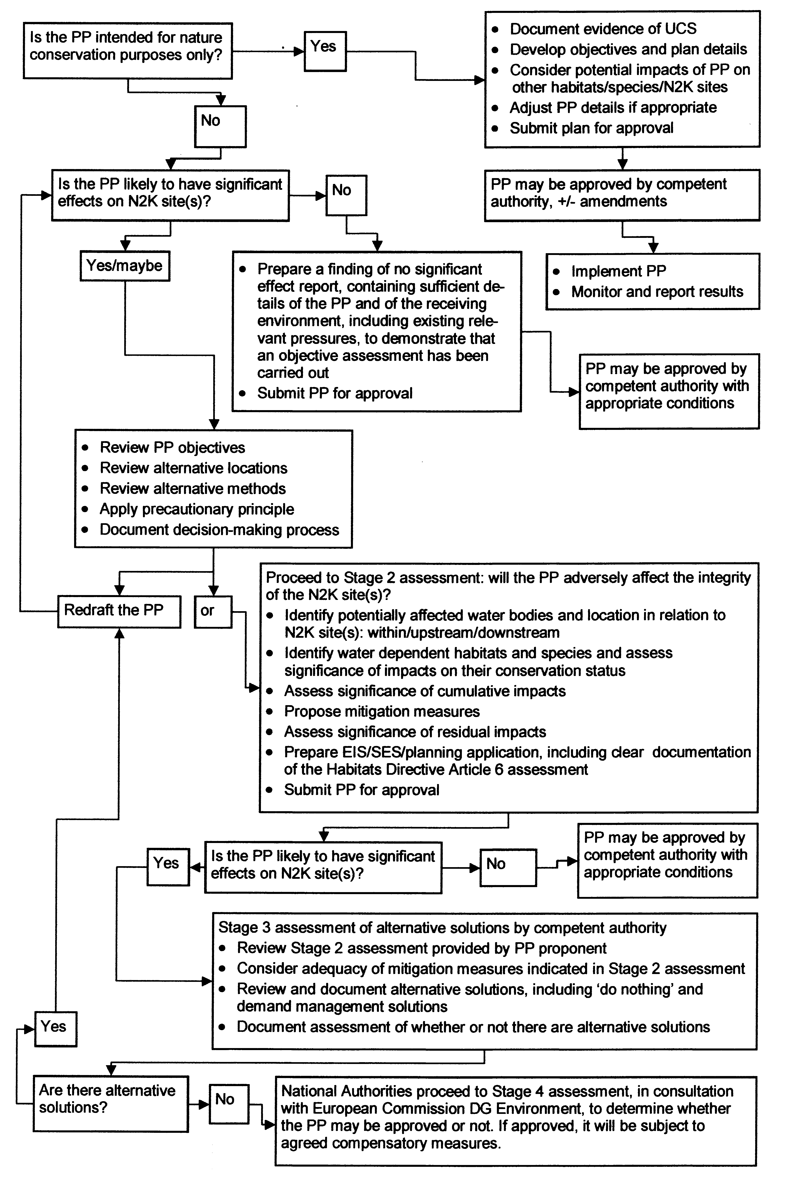
Flow diagram of the four stages of the Article 6 assessment process, modified from: Assessment of plans and projects significantly affecting Natura 2000 sites; Methodological guidance on the provisions of Article 6(3) and (4) of the Habitats Directive 92/43/EU. DG Environment © European Communities 2002. Readers should refer to this guidance.
2222222222222222
333333333
444
111111111111111111111111111
The flow diagram on the previous page illustrates the basic ‘don’t go there’ principle for potentially damaging developments in SACs and SPAs. The aim of these designations is to protect and if necessary improve conditions for rare habitats and species. The preferred option is the avoidance of adverse impacts by putting the development somewhere else. There are very few circumstances where it can argued that the only available option is to damage the conservation interests of an internationally important site, as demonstrated in case law under the Habitats and Birds Directives. The full implications of proceeding through the planning process with an inappropriate option adversely affecting an SAC or SPA should be considered during the screening stage for any development plan or project.

Stage 1: Screening.

A number of questions arise at Stage 1 screening:

1. Is there a difference between an Appropriate Assessment and an Article 6 assessment?
No, they are different terms for the same process, appropriate assessment is a term used in Article 6 of the Habitats Directive.

2. How do you know when an Article 6 assessment is required?
The formal notification of each SAC and/or SPA site by the Minister (through the National Parks and Wildlife Service of the Department of the Environment, Heritage and Local Government) includes a list of Notifiable Activities. These are defined as operations likely to alter, damage, destroy or interfere with the integrity of the site, and under current national legislation they can be carried out only with the consent of the Minister. These activities could be projects or work carried out by landowners or occupiers, or activities by, licensed by, or requiring the permission of another Minister, Public Body, State or Local Authority. However, it should be noted that the recent European Court of Justice judgment against Ireland in case C-418/04 raises issues relating to consent being granted for plans and projects which damage the integrity of an SAC or SPA, which will have to be addressed under national legislation, and it is understood that new Regulations are being drafted currently.

In general terms, activities by land owners and occupiers, Public Bodies, State or Local Authorities must be notified, and it is a Ministerial function as to whether an Article 6 assessment is required for an individual activity notified for a particular location within an SAC or SPA. Activities which are subject to licensing or planning permission will require an Article 6 assessment if they are proposed for a location within an SAC or SPA, however a requirement for an Article 6 assessment will also arise for a plan, proposal or development located outside an SAC or SPA if there is a possibility that the conservation interests of the protected site could be adversely affected by the proposed activity. If in any doubt, clarification should be sought either from NPWS directly, or from the Development Applications Unit of DoEHLG. It is an offence to carry out notifiable activities without consent, and the perpetrator can be made liable for remedial works to restore damaged areas to their former condition.

An example of a notifiable activity is: “Altering watercourses or wetlands, including changing the height of the water table, blocking or altering the flow of water or deepening any channel”. This type of activity could arise from a range of projects, including for example:
- Maintenance of existing drainage ditches by a land owner or occupier (this type of activity may be covered by a farm plan agreed with NPWS, but advance notification may still be required)
- Maintenance work on an existing drainage scheme by OPW, or maintenance of a navigation channel by Waterways Ireland or by a Port Company/Authority
- Ground or surface water abstraction, including increasing or altering the rate of an existing abstraction
- Ground or surface water discharges, including altering the volume or characteristics of an existing discharge
- Flood protection/alleviation schemes

Activities including those listed above do not necessarily have to be located within an SAC or SPA in order to have an adverse effect on its integrity; excavation and trenching work in a karst area could affect ground water flow to one or more sites designated for turlough or fen habitats, for example. A water abstraction outside an SAC could impact on surface or ground water dependent habitats or species in an SAC, or on a protected species in a river downstream of the abstraction point, by reducing flow and/or by reducing dilution or assimilative capacity for existing point discharges and diffuse silt and nutrient loadings. A water abstraction from a lake could impact adversely on any ground water dependent habitats or protected species associated with the lake, whether or not the lake habitat itself is listed as a qualifying interest for an SAC, or noted as being at unfavourable conservation status.

3. The Plan or Project is intended to benefit nature conservation in an SAC or SPA, or for a protected species, is an Article 6 assessment required?
Yes. Water Framework Directive Measures and River Basin Management Plans, or other plans which address unfavourable conservation status issues for water dependent habitats and species, must be subject to an Appropriate Assessment. The National Parks and Wildlife Service is the Competent Authority. As outlined in the flow chart, the evidence of unfavourable conservation status should be documented; this will include analysis of the pressures and pathways that are contributing to adverse effects on the habitat and/or species. Following from this analysis, the objectives and details of the plan can be developed in consultation with NPWS.

The details of the plan should then be reviewed, to assess whether they have a potential to give rise to pressures on other protected species or Natura 2000 sites, and adjusted if appropriate prior to approval and agreed implementation schedule. For example, the excavation of ponds to create habitat for Annex 4 listed Natterjack Toad Bufo calamita may cause local hydrological changes which could have an adverse effect on Annex 2 listed Vertigo species; adjustments to pond design and location could avoid adverse effects on Vertigo, or enhance habitat for them also.

Finally, monitoring programmes for the plan should be agreed and implemented, so that the effectiveness of the plan can be reviewed and any subsequent adjustments agreed and implemented.

4. How do you set the boundary of the area to be included in the Article 6 assessment?
The initial screening stage involves setting the boundaries of the assessment of significant effects, and these will vary with the type of project, the proposed location(s) in relation to water dependent protected sites and species, existing pressures, and other proposed plans or projects. The considerations that may be relevant follow from the preparation of a detailed description of the plan or project.

4.1. Project description
What is the purpose of the plan or project? What are the characteristics of the proposal, during the construction and operational phases? What pressures arise from the proposal, to what water bodies, and what waste loads may be generated? Would the proposal generate silt and/or nutrient loadings to watercourses, and would these arise in the construction and/or operational phase? Where can the project be located? (there may be a number of options).

Screening assessments should be carried out without considering the mitigation measures that form part of a project or plan. This ensures the application of the precautionary principle of avoiding potential impacts on protected sites and species in the first instance.

4.2. What types of water dependent habitat and species issues potentially arise?
For all types of water dependent habitats and species, the boundary of the area to be included in the Article 6 assessment will depend on the outcome of the review of issues that potentially arise in the context of the project description and location. It is recommended that the Development Applications Unit of the DoEHLG is consulted at an early stage of the Stage 1 screening process, so that relevant NPWS staff can provide appropriate inputs. It should be remembered that while Article 6 assessment refers specifically to SACs and SPAs designated under the Habitats Directive and the Birds Directive, there are also requirements under national legislation to avoid adverse impacts on Natural Heritage Areas (NHAs) and proposed NHAs, and on protected species wherever they occur. Protected species and habitats do occur outside areas currently subject to conservation designations, and these must be taken into account when encountered during survey work carried out in connection with appropriate assessments. The issues that may arise will vary somewhat with the type of water dependency relevant to the location of the proposal, and may include the considerations outlined below:

Transitional waters and coastal onshore habitats –
Are SACs with water dependent coastal marine, coastal transitional, and/or coastal onshore habitats present, and are any water dependent species associated with them or present in the area? Are SPAs present, and would the proposal affect feeding, breeding or roosting areas and habitats used by birds – what species and numbers could be affected, and how do these numbers relate to threshold levels for national and international importance? Are existing erosion and deposition patterns understood? How would the proposal interact with these? Do existing habitats provide protection from storm surges to other water dependent habitats? Is the project viable in view of the most recent estimates of sea level rise associated with climate change, or would it exacerbate climate change impacts? Have muddy intertidal areas in which pollutants are likely to accumulate been identified, and have sediments been sampled?

Surface water –
Is the proposal in (the catchment of) a surface water body associated with a nature conservation site or sites, and are there water dependent habitats and/or species in the site? Are there protected water dependent species elsewhere in the catchment? Are the protected water dependent habitats and species upstream or downstream of the location of the proposal, and do they have associated ground water dependent features? If SPAs are present, could the proposal affect habitats used by birds, or would disturbance issues arise? Are water dependent habitats other than Habitats Directive Annex 1 listed habitats present and could they be affected – would this reduce existing wetland buffer zones contributing to flood storage, or to nutrient and or silt load reduction?

Ground water –
Is the ground water body affected by the proposal associated with a nature conservation site or sites, and are there surface and/or ground water dependent habitats and/or species in the site? Have the zones of contribution been delineated for ground water dependent habitats and species? Are there protected water dependent species which could be impacted elsewhere in the surface catchment or zone of contribution of the ground water body? Has detailed groundwater vulnerability mapping been completed for the area? If a water abstraction, does the proposal relate to an existing spring, or to a borehole? What other abstractions relate to the ground water body?

Precipitation dependent habitats –
Is the proposal in or adjoining an SAC or SPA identified as including precipitation dependent habitats, and would it affect the hydrology of the protected area? Are the groundwater support functions potentially affected? Is there evidence that the hydrology of the protected area is already damaged? What precipitation dependent habitats are present, including bog woodland? Have areas of ground water dependent flushed habitats been identified, and are ground water dependent species associated with them? Interference with flushed areas may trigger land slides, does the proposal avoid such areas? Are there water dependent species in watercourses downstream of the proposal which could be adversely affected by increased nutrient or silt loads?

Adequacy of existing information -
Is there enough existing information to answer the questions with certainty? What studies should be carried out to clarify issues that may arise, and do these vary between different options under consideration? Are the locations and existing conservation status of the water dependent habitats and species known, and what existing pressures on them can be identified from Conservation Status assessment reporting by NPWS? Do risk assessments carried out under the Water Framework Directive, or ground water vulnerability mapping, provide useful information? What are the existing pressures that need to be taken into account in assessing cumulative impacts? Are there existing Surveillance, Operational or Investigative monitoring data relevant to the proposal?

5. Is the plan or project likely to have significant effects on N2K (Natura 2000) sites?

Arising from the Stage 1 screening assessment, the answer to this question is either no, or yes/maybe. If the screening indicates that significant effects will not arise, the process followed and reasons for arriving at this conclusion must be documented and submitted to the NPWS in the case of a notifiable activity, or to the Competent Authority in consultation with NPWS in the case of a planning or license application. It is then a matter for these agencies to respond to the proposal.

If the Stage 1 screening assessment indicates that significant effects may or will arise, the proponent of the plan or project should undertake a thorough review of their options. For example, the objective of the project could relate to a 25% increase in the capacity of a public water supply, and the main option considered was to increase an existing abstraction by 30% to include some provision for extra capacity for unforeseen contingencies. A review of the overall supply scheme could indicate that 30% of the existing treated water was being lost through supply system leakage, and that a major commercial user would be in a position to significantly reduce their water requirement. Having documented all of these issues, a Local Authority in this situation would have a basis for a funding application for the replacement of the problematic water mains.

In another example, the Stage 1 screening assessment could indicate that an existing abstraction was implicated in an unfavourable conservation status assessment for a ground water dependent Habitats Directive Annex 2 listed species which is highly sensitive to hydrological impacts. In this case, it would be necessary to reduce the existing abstraction to a volume compatible with the ecological requirements of the species in question, and to find an alternative water supply from a different water body.

In a third example, a Stage 1 screening assessment could indicate that an abstraction would lead to adverse impacts on a surface water dependent Habitats Directive Annex 2 listed species, because of existing pressures on water quality and sediment loadings which would be exacerbated during low flows. In this case, it would be necessary to establish whether a measured reduction in the existing pressures would be sufficient to allow the abstraction of a specified volume of water to proceed. If the species concerned was already at unfavourable conservation status, it would be necessary to do more than maintain the status quo by way of remedial measures to reduce existing pressures, because River Basin management measures would be required under the

Water Framework Directive – Water Status: identifying and ranking of Nature Conservation Designated Areas (2005). Prepared by Compass Informatics Limited and Natura (Environmental Consultants) Ltd. Geadóid Ó Riain, Katherine Duff and Maria Long. Environmental RDTI Programme 2000-2006 (2002-W-DS-10).
The Status of EU Protected Habitats and Species in Ireland. National Parks and Wildlife Service, 2008. Available on www.npws.ie . The detailed conservation status assessments are also available on this website
Water Framework Directive – Water Status: identifying and ranking of Nature Conservation Designated Areas (2005). Prepared by Compass Informatics Limited and Natura (Environmental Consultants) Ltd. Geadóid Ó Riain, Katherine Duff and Maria Long. Environmental RDTI Programme 2000-2006 (2002-W-DS-10).
The Status of EU Protected Habitats and Species in Ireland. National Parks and Wildlife Service, 2008. Available on www.npws.ie . The detailed conservation status assessments are also available on this website
Article 10 of the Habitats Directive refers to features of the landscape which are of major importance for wild flora and fauna, by virtue of their linear and continuous structures (such as rivers with their banks or the traditional systems for marking field boundaries) , or their function as stepping stones (such as ponds or small woods). These features are essential for the migration, dispersal and genetic exchange of wild species. Member States are required to endeavour, where they consider it necessary, in their land use planning and development policies, to encourage the management of these features of the landscape, with a view to improving the ecological coherence of the Natura 2000 network.
Council Directive 92/43/EEC
Assessment, monitoring and reporting under Article 17 of the Habitats Directive: Explanatory Notes and Guidelines. Final Draft 5, October 2006. DG Environment.
Commission decision of 12 November 2007 adopting, pursuant to Council Directive 92/43/EEC, a first updated list of Sites of Community Importance for the Atlantic biogeographical region (2008/23/EC), lists 413 sites. One of these (Site Code 000158; Lough Akibbon and Gartan Lough) is now listed as a sub-site of SAC Site Code 002176 Leannan River, Co. Donegal.
Implicit in the ‘natural range’, ‘representativity’, and ‘coherent network’ considerations in Article 1 (e), Article 2 (1 and 2), Article 3, Article 4, Article 10, and Annex 3 of the Habitats Directive
Oliver (2007). Conservation Status Assessment Report: Coastal Lagoons (1150). Available on www.npws.ie
Presence and qualifying presence in SACs is noted in the relevant data field _1303_Rhinolophus_hipposideros in the SAC_Water_Dependency database. The species is included in the WDS_Q and WDS_P fields where a cave roost is used (cross-refer to water dependent habitat _8310_Caves not open to the public).
It may be assumed that all habitats will be sensitive to some dangerous substances, however this issue requires further review and study.
Diffuse inputs to groundwater may be a significant source of eutrophication. Discharges to groundwater may not be common, those situations where they occur are taken into account.

