Ian Donohue^{1,2}, Martin L. McGarrigle³ and Paul Mills⁴ Linking catchment characteristics and water chemistry to the ecological status of Irish rivers
( Submitted to Water Research)
¹Department of Zoology, Trinity College, University of Dublin, Dublin 2, Ireland
²Centre for the Environment, Trinity College, University of Dublin, Dublin 2, Ireland
³Environmental Protection Agency, John Moore Road, Castlebar, Co. Mayo, Ireland
⁴Compass Informatics, 19 Grattan Street, Dublin 2, Ireland
Keywords: monitoring, rivers, nutrients, ecological quality, risk, catchment

Abstract
Requirements of the EU Water Framework Directive for the introduction of ecological quality objectives for surface waters and the stipulation that all surface waters in the EU must be of ‘good’ ecological status by 2015 necessitate a quantitative understanding of the linkages between catchment attributes, water chemistry and the ecological status of aquatic ecosystems. To this end, we analysed the lotic ecological status, as indicated by an established biotic index based primarily on benthic macroinvertebrate community structure, of 797 hydrologically independent river sites located throughout Ireland in conjunction with data on both physical and biotic catchment attributes and water chemistry. Highly significant inverse associations were found between the ecological status of rivers and measures of catchment urbanisation and agricultural intensity, densities of humans and cattle and chemical indicators of water quality. Overall, however, at the catchment scale, the application of stepwise logistic regression suggested that urbanisation, arable farming and extent of pasturelands are the principal factors impacting on the ecological status of streams and rivers in Ireland. Further, we show that the likelihood a river site will comply with the demands of the EU Water Framework Directive, and be of ‘good’ ecological status, can be predicted with reasonable accuracy using simple models that utilise either widely available landcover data or chemical monitoring data. Non-linear landcover and chemical ‘thresholds’ derived from these models have the potential to be of use in the management of risk and as a planning tool in catchments and suggest strongly that more careful planning of land-use in Ireland is essential in order to restore and maintain water quality as required by the Directive.

Table 3. Results of non-linear regressions between the catchment attributes and chemical variables included in the logistic regression models (see Table 2) and the estimated probability of attaining ‘good’ ecological status. Predicted values of the dependent variables at probability 0.75 and their 95% confidence intervals are also shown.
Dependent variable | Model | F | df | p | r² | Predicted threshold  (probability 0.75) | 95% C.I.
Urban area (%) | Log: y = -0.52-1.89*ln(x) | 10200.9 | 795 | <0.0001 | 0.93 | 0.03% | 0-2.6%
Pasture (%) | Quadratic: y = 44.84+186.81x-261.69x² | 1219.3 | 794 | <0.0001 | 0.75 | 37.7% | 6.7-68.7%
Arable land (%) | Quadratic: y = 20.87-37.79x+15.63x² | 211.2 | 794 | <0.0001 | 0.35 | 1.3% | 0-14.4%
MRP (µg L⁻¹) | Log: y = 12.6-30.77*ln(x) | 961.2 | 223 | <0.0001 | 0.81 | 21.5 µg L⁻¹ | 0-84.9 µg L⁻¹
Conductivity (µS cm⁻¹) | Quadratic: y = 593.96+356.67x-1026.6x² | 404.6 | 222 | <0.0001 | 0.79 | 284 µS cm⁻¹ | 71-500 µS cm⁻¹
Ammonia (µg L⁻¹) | Log: y = 7.57-74.67*ln(x) | 645.3 | 223 | <0.0001 | 0.74 | 29.1 µg L⁻¹ | 0-216.6 µg L⁻¹

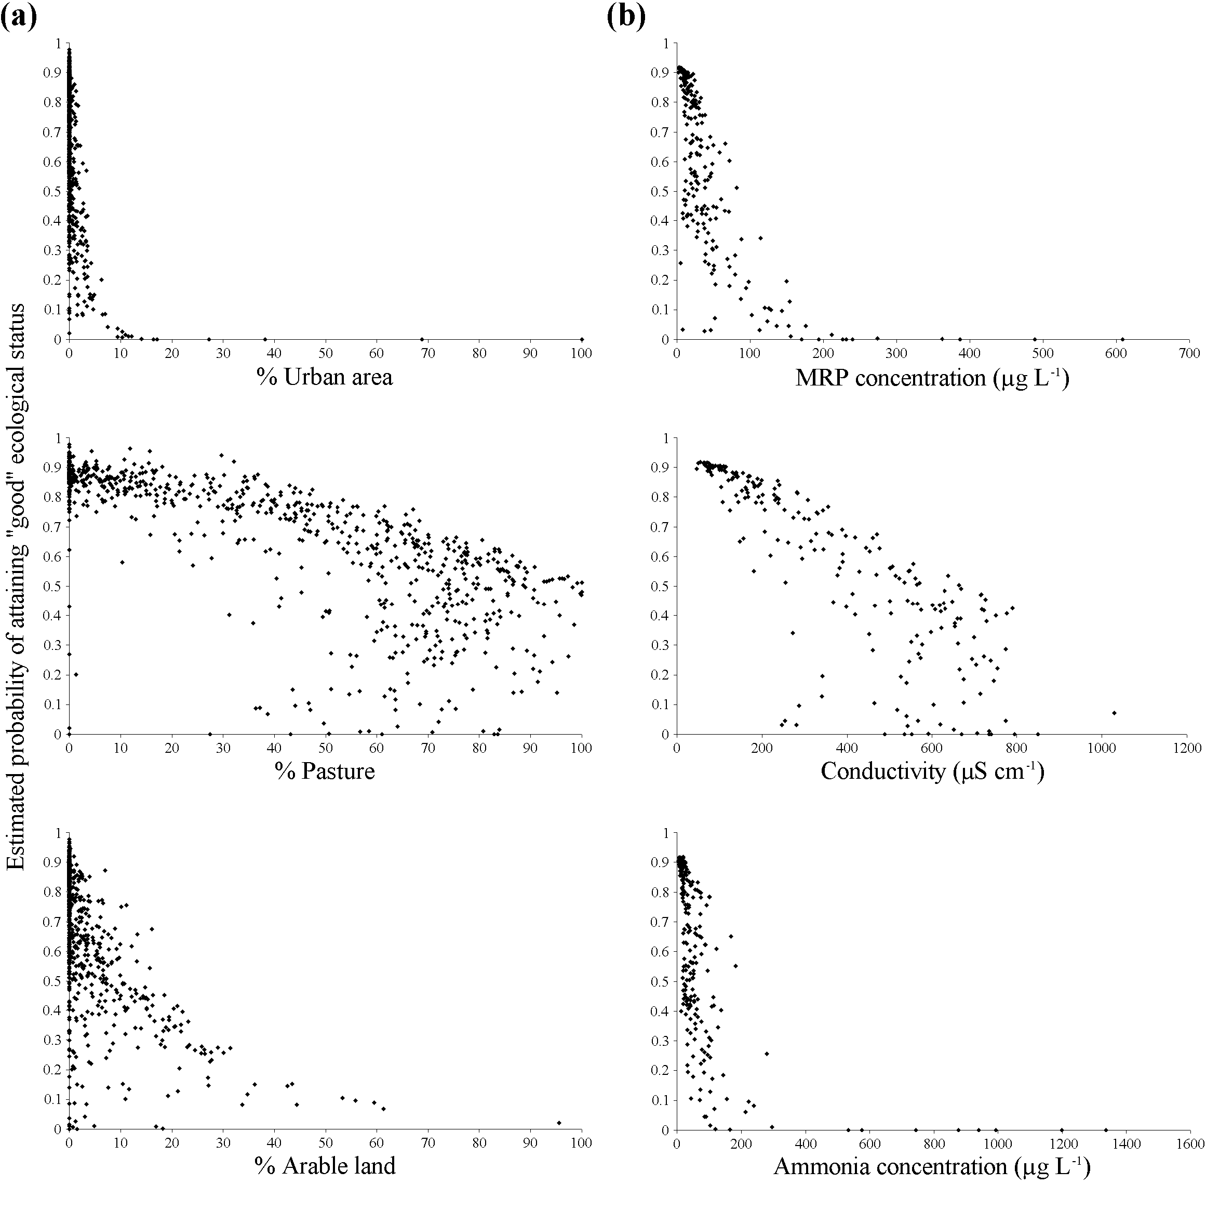

Fig. 2. Estimated probabilities of attaining ‘good’ ecological status sensu the EU Water Framework Directive (i.e. Q-value ≥4) for river sites varying in landcover and chemical attributes as predicted by the logistic regression models based on (a) catchment characteristics and (b) river chemistry.

